Coffee: The World in Your Cup
Burke Museum of Natural History & Culture
Summative Evaluation
New Directions Project
Spring 2009

Report prepared by Nick Visscher
Reviewed by Kris Morrissey and Kathryn Owen
Research Team listed in report

Funded by


Executive Summary of Key Findings

- Incoming visitors appear to have a pre-existing strong personal association with coffee consumption and purchasing. Nearly 100 percent of Coffee exhibit visitors identify themselves and coffee drinkers.

- The majority of visitors surveyed are first-time visitors to the Coffee exhibit.

- Data suggests that visitors to the coffee exhibit are highly engaged (mean time 19.3 seconds with sweep rate of 103.6)

- Adults visiting with other adults spend significantly more time in the exhibit than individual adults or adults with children.

- The introductory section of the exhibit appears to be under-utilized (only 30% of visitors stopping).

- Visitors surveyed upon exit feel more informed about coffee growing, production and distribution than visitors surveyed before entering the exhibit.

- Visitors surveyed upon exit are more aware of coffee growing certifications and are more likely to consider socially and environmentally responsible coffee production when making a coffee purchase.

- The exhibit is successful in impacting visitor attitudes. Over half of visitors surveyed upon exit, and nearly half of visitors surveyed six weeks later say the exhibit impacted their attitudes toward coffee growing, production and distribution.

- A small set of visitors surveyed indicated that their coffee buying behavior had changed as a result of their exhibit experience. However, many visitors to Coffee indicate that they already incorporate socially and environmentally responsible coffee buying behavior into their everyday lives.

Introduction
The exhibit Coffee The World in Your Cup was designed by and installed at the Burke Museum of Natural History and Culture running from January 24, 2009 through September 7. The exhibit presents the story of one of the world's most widely traded commodities and how it has affected cultures, economies, and environments across the globe. Coffee explores the environmental and social impacts of the coffee industry and recommends ways for consumers to make socially and environmentally responsible coffee purchases at the grocery store or in a coffee shop. The exhibit space is approximately 2,000 square feet.

The New Directions project was invited to conduct a summative evaluation of the exhibit that would measure the impact of the exhibit, identify areas for adjustment before the exhibit travels and create a baseline of visitor data for future Burke exhibits.

New Directions is an IMLS funded project designed to train museum studies graduate students to understand, support and engage in audience research. A key component of the training is using museums as learning laboratories where students work with the institution to conduct audience research, under the guidance of evaluation mentors.

To prepare the evaluation framework, students in the New Directions project met with a number of core staff involved in the exhibit. The following report includes results from data collected during the months of April and May 2009. The project consisted of two parts: tracking and timing of visitors in the exhibit and an exit interview offered to three separate audience groups (pre-visit, immediate post-visit, and approximately 6 weeks post-visit). All aspects of this research were reviewed and approved by University of Washington’s Institutional Review Board for Human Subjects Research.

Goals: Assess exhibit experience, assess exhibit impact
- Describe the nature of the exhibit experiences for adult and family visitors.
- Assess responses of visitors to the museum’s intended messages and motivations for behavior change related to the coffee trade.

Evaluation Questions
- How do visitors move through the exhibit space?
- How much time do visitors spend in the exhibit space?
- How much time do visitors spend viewing the introductory video “Origins”?
- What are the attitudes and behavior of visitors toward coffee growing & purchasing before, immediately after, and 6 weeks after visiting the exhibit?

Methods

Tracking and Timing
Visitor observations began in April of 2009. A random sample of 173 visitors were observed with timing and tracking collected on 90 visitors and tracking only on an additional 83 visitors. When group were involved, one member was selected and followed throughout their visit. Students used tracking maps to observe visitor movement throughout the exhibit. The timings were used to calculate Sweep Rate Index (SRI), which is a square foot per minute measurement of visitor movement through the exhibit. The SRI has been validated in national studies as a measure and estimate of visitor engagement and learning (Serrell, 1998). Visitor stops were recorded as three seconds with both feet firmly planted on the ground, with attention focused on the exhibit.

Visitor tracking was conducted to identify which areas in the exhibit are receiving most attention and identified under-utilized areas. While tracking, students also recorded total time in exhibit, and total time in video. In an effort to simplify data collection, 90 separate timings (of total time and video time) were conducted in addition to the 83 visitor tracking observations.

Visitor Surveys
A web-based survey was administered to visitors, comparing responses of those who took the survey before, immediately after and 6 weeks later. Questions attempted to measure current coffee purchasing behavior and whether or not the exhibit influenced or changed attitudes and behavior with regard to coffee purchasing.

Statistical Analaysis
The use of Analysis of Variance (ANOVA) assisted in helping to determine statistically significant relationships between testing groups and other test categories. Statistical significance was assessed at the .05 alpha level, a standard level of significance within the field of audience research. Results below indicate significance where applicable.

Results

Timing
- Visitors spent between 33 seconds and 75 minutes in the exhibit. The mean time in the exhibit was 19.3 and the median was 14.8.
- The average sweep rate was 103.6. The sweep rate index (SRI) was calculated dividing the exhibit square footage (2000 square feet) by the mean visit time of 19.3 minutes. Sweep rates of less than 300 square feet per minute indicate that visitors are moving slowly, stopping often, or spending more than a few seconds at each stop. A SRI of just over 100 suggests an exceptionally high level of engagement.
- ANOVA revealed that there was a statistically significant difference in total exhibit viewing time between visitor groups, F(2,87)=5.713, p=.005
- Tukey post-hoc analysis showed there was a significant increase in exhibit stay time between Adult groups (M=1543) and both Adults alone (M=887), p=.011 and Groups of adults and children (M=840), p=.027. (See figure 1)
- Average time spend watching video was 8.4 minutes. There were no significant differences between groups in video viewing time.

Table 1. Total Time Spent in Exhibit Gallery
(N=90)
Mean time (minutes) | 19.3
Range (minutes) | 33sec – 75min
Median (minutes) | 14.8

Table 2. Total Time Spent in Exhibit Video “Origins
Sample: 53 visitors (59% of total sample stopped in video)
Video Length: 13 minutes
Mean time (minutes) | 8.4
Range (minutes) | 3sec – 22min
Median (minutes) | 9.95

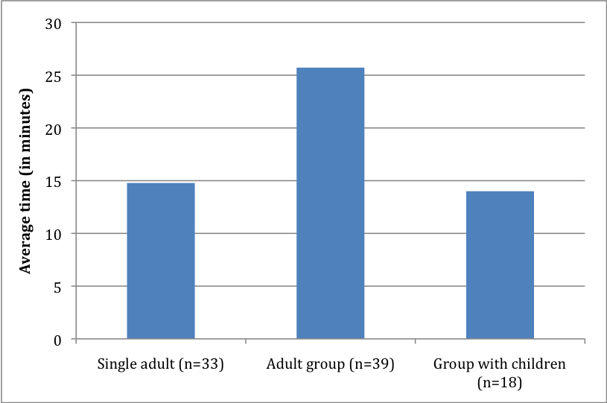
Figure 1. Total visit time comparison by group composition

Tracking
- Fifty-Seven Percent of visitors entered to the left while 43% of visitors chose to enter the gallery space to the right (See figure 2). The quadrants to the left contained the unique additions of a Barista cart, and tables with coffee related games. The hands-on, interactive nature of these elements may be important features to include in future Burke exhibits based on the attracting power of this particular feature.
- Tracking maps showed that half of exhibit visitors stopped in at least 50 percent of the exhibit quadrants.
- Exhibit areas where visitors most frequently stopped included the Coffee bean farming information titled, “The Farm”, and the banners on the north wall detailing the environmental and social issues surrounding coffee growth and production. Areas with least frequent stops included the introductory panels and display.

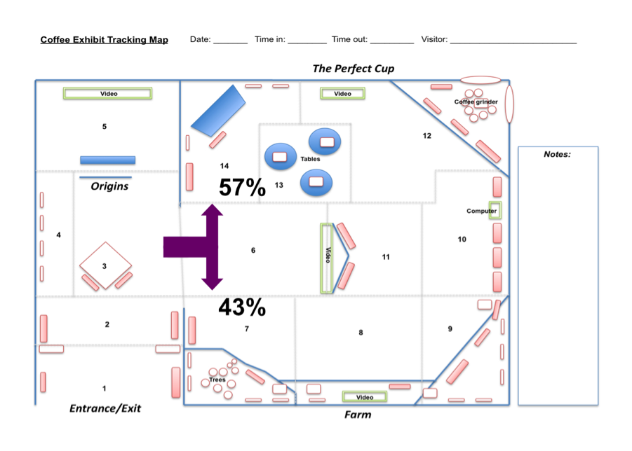
Figure 2. Tracking Map with Entry Directions

Tracking maps were divided into specific quadrants, based on conceptual element groups within the exhibit space. Table 3 describes the content of each quadrant and the percentage of visitors who stopped in each quadrant. More that half of the 83 visitors tracked stopped in 50 percent of the quadrants.

Table 3. Percentage of visitors who stopped in each exhibit quadrant.
Quadrant | Stopped (%)
1. Entrance | 30
2. History | 49
3. Coffee ceremony | 49
4. Wall images | 34
5. “Origins” video | 47
6. Google maps video | 33
7. Bean biology | 58
8. The farm | 65
9. Farming | 55
10. Social/Environmental Issues | 65
11. Health effects and trade | 36
12. Roasting | 67
13. Tables | 54
14. Espresso cart | 51

Most and least used exhibit quadrants
Figure 3 shows the quadrants where the most and least stops occurred and Figure 4 shows the quadrants that had the least amount of foot traffic (i.e. quadrants where visitors did not pass through at all). Introductory graphics and displays were least frequently stopped at and panels explaining the social and environmental Issues surrounding coffee production were most frequently stopped at. Quadrant eight dealing with farming aspects of coffee was also a high traffic area.

Although quadrant numbers 4 and 11 were shown to have low foot traffic however, it was noted that these elements are extremely easy to view from adjacent quadrants. It is possible that displays were viewed and read from a distance.

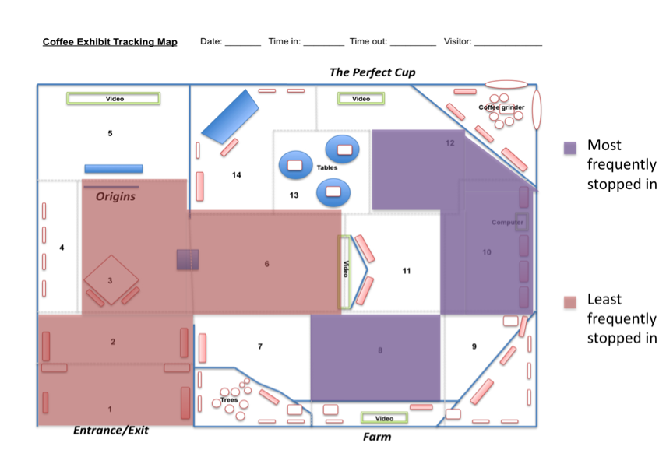
Figure 3. Tracking Map showing least and most frequently stopped in areas

Visitor Surveys

Sample Demographics

Total Size: 79 visitors
- Pre Visit: 26 Visitors
- Immediate Post-Visit 36 Visitors
- Six Weeks After Visit 17 Visitors* (*25 emailed, 17 responders)

Exhibit attendance (only asked to Post-Visit, and 6 Weeks Post-Visit), (n=53)
- 90.6 % were having their first visit.
- 9.4 % had been 2-3 times including their surveyed visit.

Coffee tasting event attendance – sponsored by Coffee exhibit
- 75.5% have not participated in a coffee tasting event.
- 18.9% participated in one coffee tasting event.
- 5.6% participated in 2-3 coffee tasting events.

Do Coffee exhibit visitors drink coffee? (n=79)
- 91.1% of visitors surveyed say that they drink coffee.
- Of the 7 visitors surveyed who said they did not drink coffee, 3 of them said that they purchase coffee for someone else and/or affect the type of coffee they buy.

How much coffee do Coffee exhibit visitors drink per week? (n=72)
- 19.4% of visitors surveyed said they occasionally drink coffee (1-3cups).
- 30.6% of visitors surveyed said they regularly drink coffee (4-7 cups).
- 26.4% of visitors surveyed said they frequently drink coffee (8-14 cups).
- 23.6% of visitors surveyed said they very frequently drink coffee (>15 cups).

How often do Coffee exhibit visitors purchase coffee drinks from coffee shops per week? (n=72)
- 15.3% of visitors surveyed said they never purchase coffee from a coffee shop.
- 65.3% of visitors surveyed said they occasionally purchase (1-3 cups).
- 13.9% of visitors surveyed said they regularly purchase (4-7 cups).
- 4.2% of visitors surveyed said they frequently purchase (8-14 cups).
- 1.3% of visitor surveyed said they very frequently purchase (>15 cups).

Responses to Specific Survey Questions

“I feel well informed about coffee growing, production, and distribution.”
(See Table 4, Figure 4)

Table 4. Percentage of visitors in each group responding “agree” and “strongly agree” to feeling well informed about coffee growing, production, and distribution.
Pre-Visit |  | Immediate Post-Visit |  | Later Post-Visit
% | N | % | N | % | N
38.5 | 26 | 91.7 | 36 | 76.5 | 17

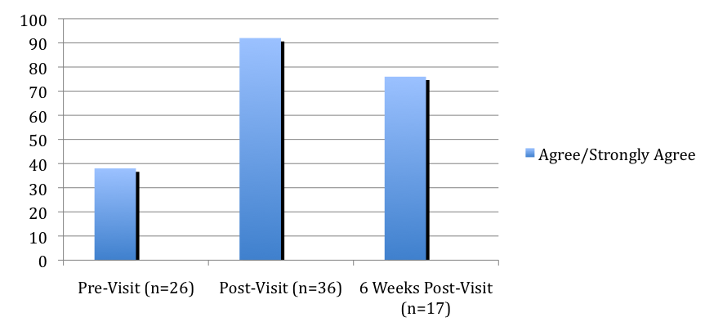
Figure 4. Percentage of visitors in each group responding “Agree” and “Strongly Agree” as well as those who responded “neutral” to the survey item, “I feel well informed about coffee growing, production and distribution.”

“Please indicate the importance of each consideration when you are purchasing coffee”
(See Table 5, Figure 5)

Analysis
- A one-way ANOVA was used to show significant differences between survey groups. Shade-Grown consideration was the only item that differed significantly between survey groups F(2, 69) = 6.49, p=.003.
- Tukey post-hoc comparisons of the three survey groups within the Shade-grown consideration indicate a significant increase in score between the Pre-Visit survey (M=2.36) and Immediate Post-Visit survey (M=3.41), p=.002. There was not a significant difference between Pre-Visit and Later Post-Visit survey for the Shade-Grown consideration.
- Although not statistically significant, there do exist noticeable differences between the considerations of each testing group. Decreases in consideration score were seen from Pre to Post-Visit surveys in price and flavor, while increases were seen from Pre to Post-Visit surveys in fair trade, organic and shade-grown.

Table 5. Percentage of visitors in each group responding“very important” and “the most important” for each coffee buying consideration.
 | Pre-Visit |  | Immediate Post-Visit |  | Later Post-Visit
 | % | N | % | N | % | N
Price | 26.9 | 23 | 11.1 | 34 | 17.6 | 15
Flavor | 92.3 | 25 | 83.4 | 34 | 82.4 | 16
Fair-Trade | 46.2 | 23 | 50 | 34 | 29.4 | 16
Organic | 23.1 | 23 | 38.9 | 34 | 29.4 | 16
Shade-Grown | 11.5 | 22 | 50 | 34 | 42.1 | 16

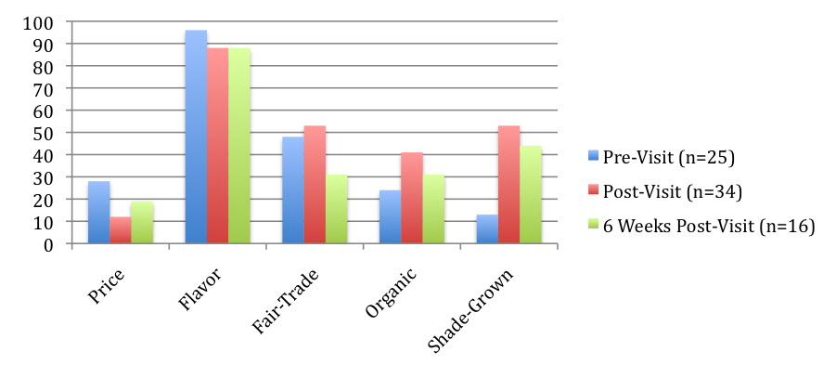
Figure 5. Percentage of visitors in each group responding “very important” and “the most important” for each coffee buying consideration.

“How familiar are you with each of these types of certification?”
(See Table 6, Figure 6)

Analysis
- A one-way ANOVA was used to show significant differences between survey groups. There were significant difference seen within the Bird-Friendly Certification survey groups F(2,70)=5.852, p=.004.
- Tukey post-hoc comparisons of the three survey groups within the Bird-Friendly Certification groups show a significant increase in awareness between the Pre-Visit survey (M=1.17) and both Immediate Post-Visit survey (M=1.82), p=.019 and Later Post-Visit survey (M=2.07), p=.008.
- Although not statistically significant, there do exist noticeable increases in awareness of each certification type in both Immediate Post-Visit and Later Post-Visit surveys.

Table 6. Percentage of visitors in each group who responded “somewhat familiar” and “very familiar” to each certification.
 | Pre-Visit |  | Immediate Post-Visit |  | Later Post-Visit
 | % | N | % | N | % | N
USDA Organic | 61.5 | 24 | 83.3 | 34 | 64.7 | 16
Fair-Trade | 76.9 | 25 | 88.9 | 34 | 88.2 | 16
Rainforest Alliance | 26.9 | 24 | 55.6 | 34 | 52.9 | 15
Bird-Friendly | 7.7 | 24 | 38.9 | 34 | 47.1 | 15
UTZ | 3.8 | 24 | 22.2 | 34 | 11.8 | 15

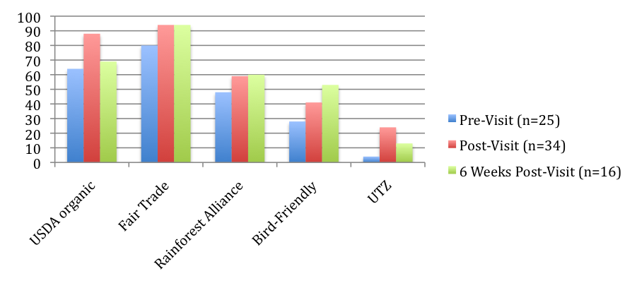
Figure 6. Percentage of visitors in each group who were “somewhat familiar” and “very familiar” with each coffee certification

“My Attitudes toward coffee growing, production and distribution are changing [or have changed] as a result of this exhibit.”
(See Table 7, Figure 7)

Table 7. Percentage of visitors in each group who responded “agree” and “strongly agree” that their attitudes toward coffee growing, production and distribution are changing, or have changed as a result of their exhibit visit
Immediate Post-Visit |  | Later Post-Visit
% | N | % | N
61.1 | 35 | 47.1 | 17

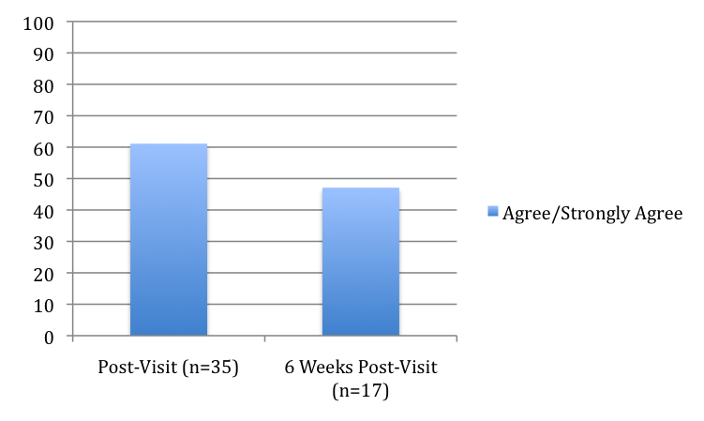
Figure 7. Percentage of visitors in each group who responded “agree” and “strongly agree” that their attitudes toward coffee growing, production and distribution are changing, or have changed as a result of their exhibit visit

“I plan to change [or I have changed] my consumer behaviors related to coffee as a result of this exhibit.”
(See Table 8, Figure 8)

Table 8. Percentage of visitors in each group who responded “agree” and “strongly agree” that their consumer behavior toward coffee purchasing are changing, or have changed as a result of their exhibit visit
Immediate Post-Visit |  | Later Post-Visit
% | N | % | N
36.1 | 35 | 17.6 | 17

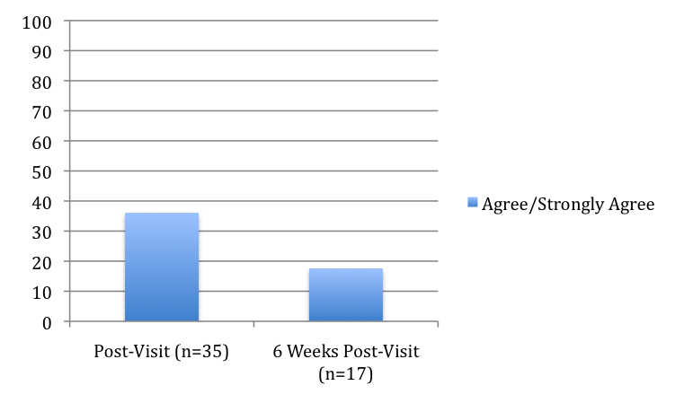
Figure 8. Percentage of visitors in each group who responded “agree” and “strongly agree” that their consumer behavior toward coffee purchasing are changing, or have changed as a result of their exhibit visit

“I plan to change [or I have changed] some of my consumer behaviors unrelated to coffee as a result of this exhibit.”
(See Table 9, 10 & Figure 9)

Table 9. Percentage of visitors in each group who responded “agree” and “strongly agree” that their consumer behavior unrelated to coffee purchasing are changing, or have changed as a result of their exhibit visit
Immediate Post-Visit |  | Later Post-Visit
% | N | % | N
19.4 | 34 | 0 | 17

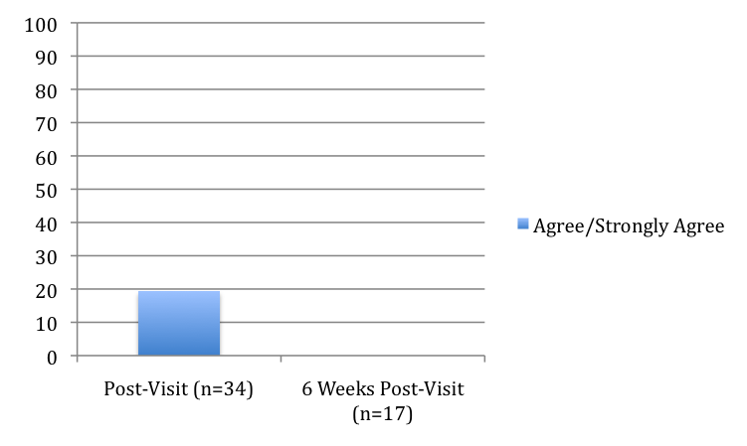
Figure 9. Percentage of visitors in each group responding “agree” and “strongly agree” that their consumer behavior toward coffee purchasing are changing, or have changed as a result of their exhibit visit

Table 10. Open-ended Visitor Comments on Attitude and Behavior Questions
Immediate Post-Visit
- “I don't drink coffee. I have recently been introduced to the fair trade label and concept with chocolate. I would like to limit my family's intake of chocolate so we can afford the fair trade products.”
- “I will seek out fair trade coffee for purchase.”
- [I am] “not changing habits, because I already use shade-grown, organic, fair-trade coffee…”
- [I] “only buy coffee that supports the workers being paid fairly and also supports sustainable development.”
- “I've been buying shade-grown fair-trade organic coffee for more than 3 years!”
- “We are going to try to be more aware of business practices and ecological impacts of stuff.
- I already look for shadegrown and organic coffee and use recycle-friendly ideas when shopping
6 Weeks Post-Visit
- “I've been buying shade-grown, sustainable, fair-trade coffee for as long as it's been available, so the exhibit only confirmed what I'm already doing. But I loved the exhibit's strong emphasis on the interconnection of workers and customers in very different parts of the world.”
- “We already knew a lot about shade grown and fair trade cafe; the exhibit was very good, but most informative if you did not know much.”
- “I will make more effort to buy coffees produced with conservational practices in mind.”

General visitor comments upon completing survey (pre, post, 6 weeks post)

Table 11. Open-ended Visitor Comments on Exhibit Experience (last item on survey)
Pre-Visit
- “I love coffee!”
- “Spent time on a fair trade coffee plantation in Costa Rica learning about coffee production and helped pick beans!”
Immediate Post-Visit
- “the print of the standing panels are too small. especially for the habit and environmental impact of the exhibit. The computer between the different display is not noticable...maybe do to low eye level?”
- “thank you. we are tourists here in seattle to see baseball games and came here on the spur of the moment, so the exhibit has been most enlightening.”
- “I particularly enjoyed political history / cofeehouse connection. Do more please.”
- “I would have appreciated more in-depth information and less promotion of sponsoring coffee providers.”
- “there needs to be more narration-what are the roasters looking for when gazing silently at the roaster? fortunately there are enough side displays to answer some of my questions.”
- “Thanks! It was a very informative and creative exhibit!”
- “Thank you for helping the community learn how to be responsible consumers! We need more exhibits like this one!”
6 Weeks Post-Visit
- “This exhibit was timely (the origins and history of coffee in an area many Americans only know as an enemy or as exotic). And (as I said earlier) the emphasis on global interconnection, and how my decisions affect someone else's kid's chance for a decent life, was excellent. Thank you!”
- “Good exhibit and interesting museum, but smaller than we had expected.”

Discussion

Exhibit Strengths
Data suggests that Coffee: the world in your cup offers an engaging experience for visitors, especially adults visiting together in a group. Based on Serrell’s criteria for a thoroughly used exhibit (1998), Coffee appears to approach benchmarks for success both in Sweep Rate Index, meaning that visitors are stopping at exhibit elements more and spending longer lengths of time within the exhibit in comparison to other observed exhibits of similar size.

The exhibit appears to attract an audience that has an already established association with coffee in their daily lives and appear to come to the exhibit with some degree of familiarity toward environmentally and socially responsible modes of coffee growing and purchasing behavior. The exhibit is successful in strengthening and reinforcing visitor’s knowledge and attitudes of coffee growing, production and distribution and in some cases plays a role in informing visitor’s coffee purchasing behavior.

Limitations
- Data was collected in a very short period and during spring when the audience is likely to be different from summer visitors.
- Students received only limited training due to the short time period of the pilot test. In some cases there were minor inconsistencies in the ways data were collected.
- When tracking visitors, some exhibit elements can be observed while visitors are standing in neighboring quadrants.
- Exhibit quadrants show thematic areas of exhibit content, but data does not provide information about specific exhibit components.

Research Team

Project PIs
Kris Morrissey, PhD Director, Museology Program University of Washington
Kathryn Owen Audience Research Supervisor Woodland Park Zoo
Reed Stevens Associate Professor, Education University of Washington

Project Support
Nick Visscher New Directions Coordinator University of Washington

Graduate Student Researchers
Marta Beyer
Liz Broughton
Rosie Clayburn
Alex Curio
Julie Dougherty
Kathryn Fromson
Jaisa Halls
Karin Hoffman
Meng-Fen Lu
Sara Martinez
Erin Milbeck
Jennifer Meyers
Jessica Newkirk
Liz Rosino
Justine Walker
Shannon Weiss

References

Serrell, B. 1998. Paying Attention: Visitors and Museum Exhibitions Washington, DC American Association of Museums.

Acknowledgements

We would like to thank Ruth Pelz and the staff of the Burke Museum of Natural History and Culture for their cooperation in this project. We would also like to thank Fred Nick and the University of Washington Center for Social Science Computation and Research for their assistance in the statistical analysis.

