Spring 2011 Report
CITY VALUE STUDY
Denver Museum of Nature & Science

9/21 & 9/24/2011
N=77

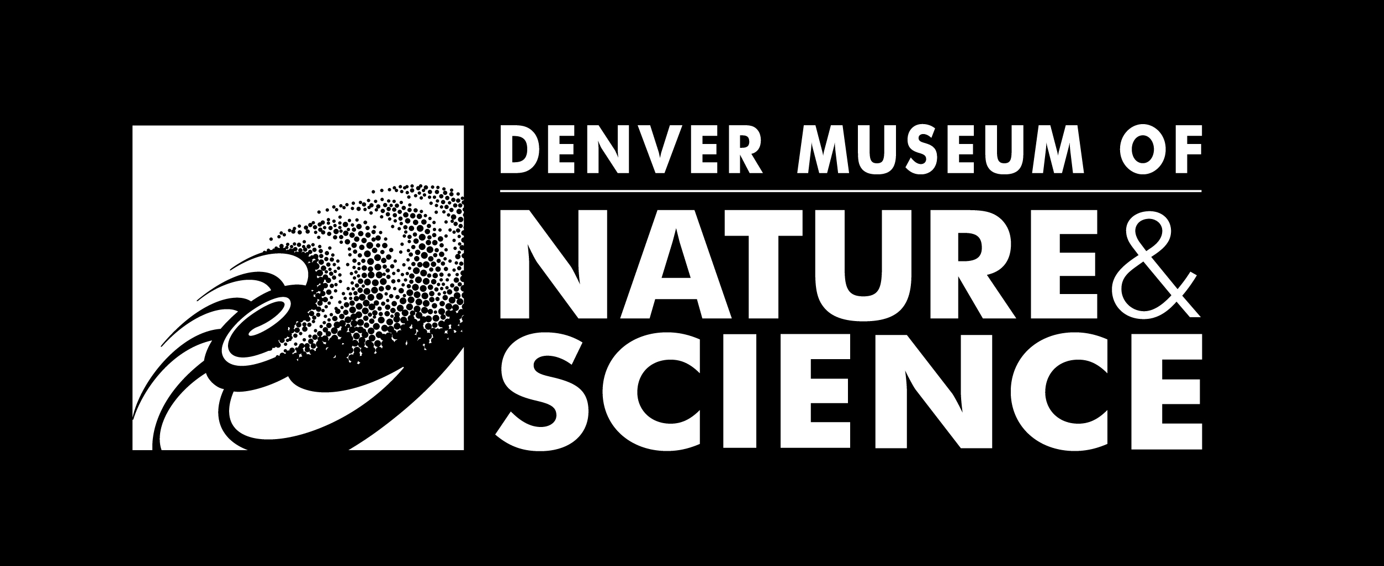

Report produced by:
Laureen Trainer
Manager of Visitor Research & Program Evaluation
Denver Museum of Nature & Science

Conceived as part the Denver Evaluation Network, the City Value Study sought to understand whether people visiting one of the cultural institutions in the Network valued that museum. Further, participants were asked to explain, in their own words, more about why they valued that particular institution; what that museum offered themselves, their family, and their community; and what other leisure options they had considered for the day. Following these interview questions, administered by DMNS Research Assistants, each respondent completed a short, demographic questionnaire.
Data collection took place on either a Wednesday/Thursday and a Saturday/Sunday at each institution. DMNS Research Assistants worked four-hour shifts and there were no free-days during data collection. RAs followed a random sampling protocol (every 3rd adult visitor) where the traffic volume allowed them to do so, other times they achieved a representative sampling by approaching every visitor. The instrument was administered as people entered the museum.

Museum participating in the City Value Study:
Buffalo Bill Museum & Grave
Butterfly Pavilion
Children’s Museum of Denver
Colorado Railroad Museum
Denver Art Museum
Denver Botanic Gardens
Denver Museum of Nature and Science
Denver Zoo
Four Mile Historic Park
Golden History Museum
Lakewood Heritage Center
Longmont Museum & Cultural Center
Molly Brown House Museum

Data collection at DMNS took place on Wednesday, September 21st and Saturday, September 24th. T-Rex Encounter, a bilingual exhibition, was open in Phipps Gallery.
Do you value the Denver Museum of Nature & Science?

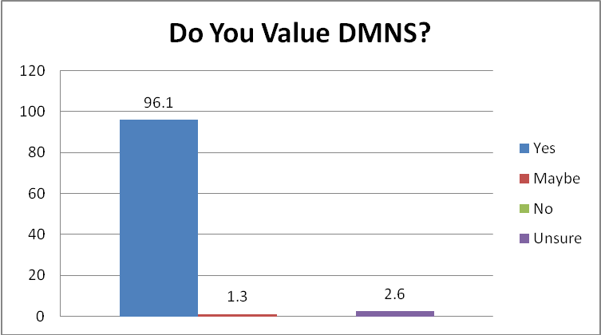

The overwhelming majority of respondents (96.1%, n=74/77) indicated that they valued DMNS. 1 person indicated a “maybe” – somewhere between yes and no. This respondent remarked that it was only their 2nd visit to DMNS. 2 people responded that they were “unsure” if they valued DMNS. Both of these people were first-time visitors it is possible that they were uncertain about what the institution offered them.

Can you tell me a little more about why?

DMNS offered an educational value to a majority of respondents.
- I think it's very educational. Find out things you didn't know and reinforces things you learned before.
- Good learning experience for everybody. See things you wouldn't see anywhere else.
- Educational experience it provides younger children and adults.
- It teaches people about space and history.

This was followed closely by the complementary ideas of DMNS having value because it is a good place for kids – as in both educational and entertaining for them – as well as a place that kids like.
- I have grandchildren who are 4 and they've been coming here for 1-2 years and it's one of their favorite places besides my house.
- Nice place to take kids and help us learn more about exhibits especially traveling exhibits. Appreciate how it has adapted to younger kids. When I was going it was geared more toward adults.
- It's a great place to go with kids. Lot of fun things to do that are educational and fun.
- Gives kids a chance to make up their own mind about how things started.
- It's fun for kids to learn, touch things, explore things they wouldn't normally see.
- Gives son a great educational and cultural opportunity that we wouldn't get where we live.

Respondents also valued the Museum because they viewed it as entertaining and unique.
- It's very interesting to us. We've been here several times and it's our first time coming without children. Unique place.
- A learning experience. Fun. Something different.
- Because there aren't any other museums around Colorado like it.

What does the Denver Museum of Nature & Science offer you, your friends and family, and your community?

Many of the dominant concepts were interlinked – for example – fun, family friendly, and education were all important pieces in the puzzle.

Again, education rose to the top when respondents thought about what DMNS offered them, their family, and their community.
- Opportunity to learn more even as an adult. I go to some of your workshops.
- An inexpensive way to educate my child. A day out. Spend time with family.
- A place to educate our children.
- Ability to study and experience things we wouldn't normally be able to do.
- Chances to see interesting science that they normally wouldn't get to see.
- A good learning environment for families.

Entertainment was also an important offering.
- Excellent entertainment value for the money. Lots of different things to explore. Good for all ages. Likes family membership.
- A place to go that's fun and educational. Kids and adults enjoy it.
- Planetarium, IMAX and museum exhibits. Entertainment and experience.

DMNS offered the community a place for families to go (family-place) and a place where parents feel good about taking their children (good-for-kids).
- A good place where kids can get hands-on experience and learn things about the environment
- A place to come and learn about things that interest my son.
- A place to go and have your kids learn different things and have fun doing it.
- A place for her (daughter) to explore. Sister has autism, so this is a good place for her to get her hands on stuff and touch.
Why did you choose to visit today?

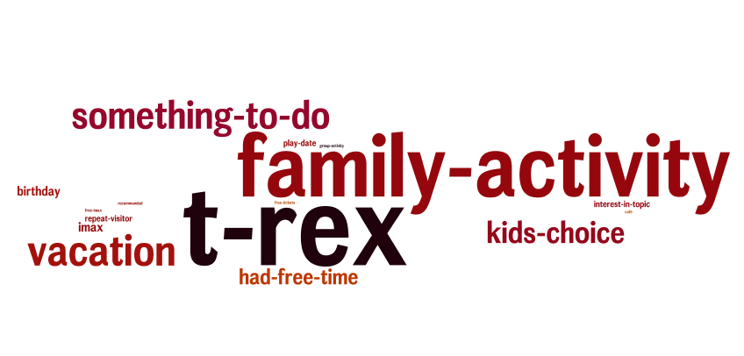

The special exhibition, T-Rex Encounter proved a big draw for many of the interviewees.
- TREX.
- Dinosaur exhibit.
- See TREX exhibit.
- Wanted to see dinosaur robots.
- Really into dinosaurs. Come for TREX exhibit.
- T-Rex, out-of-town company.

The idea of DMNS as a place for families to spend time together was another major reason for respondents choosing to visit the Museum.
- Older daughter has been wanting to come. She is reading Mummies in Morning.
- Celebrating daughter's first birthday.
- Be with grandma.
- Kids wanted to go.
- Wednesday and it's our day and that's what she (daughter) wanted.
- Visiting my daughter and wandering around Denver and decided to stop in.

In many cases kids and dinosaurs both played a role in the decision to visit.
- Son wanted to come to see dinosaurs.
- Little boy is going to 3 and he love dinosaurs.
- My son saw exhibit of TREX on nightly news and wanted to come.
- Come to see dinosaurs. Home with grandkids.

Can you tell me more about some other things you might have done today, if you hadn’t decided to visit the Denver Museum of Nature & Science?

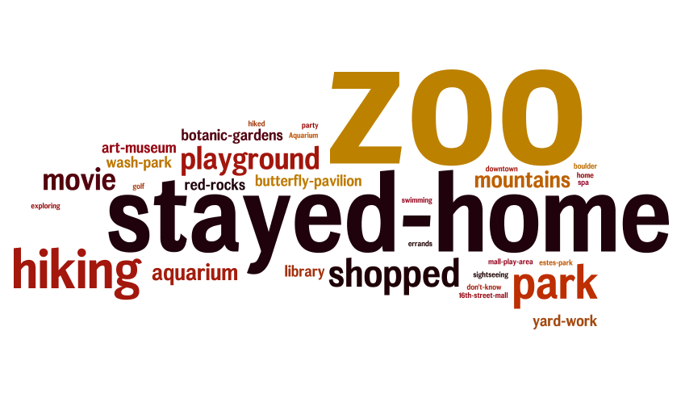

23 people also considered visiting Denver Zoo on the day they visited DMNS. A similar number of respondents (n=14) would have stayed home (to clean cook, do yard work, read, or sit around) if they had not visited. Several outdoor activities were mentioned, including going hiking, going to a park or playground, or heading to the mountains.

Quantitative Data

Number of adults in your group (including you):
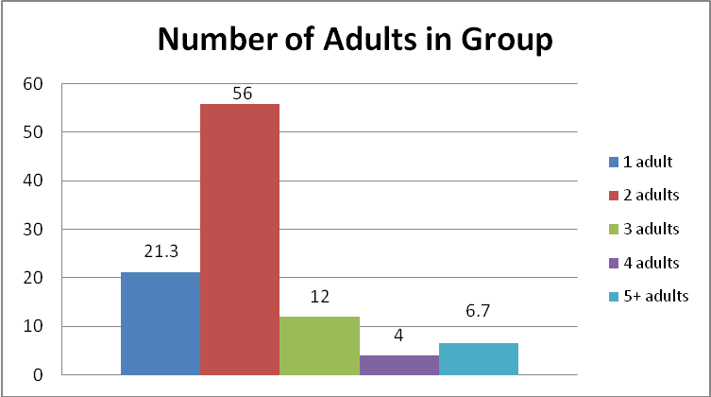
The majority of respondents came in groups with at least two adults (78.7%, n=59/75).

Number of kids in your group:
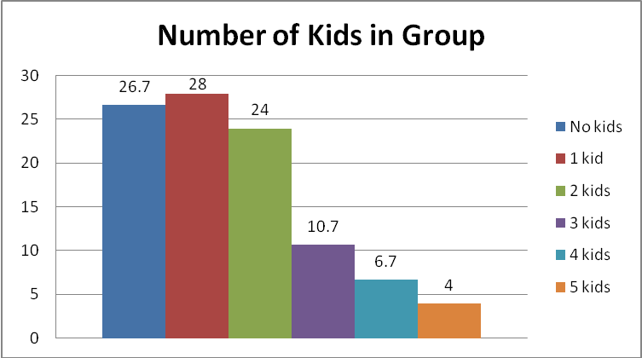
One-quarter of adults (26.7%, n=20/75) did not bring any children to the Museum. Of those adults who did bring kids, the majority (70.9%, n=39/55) brought 1-2 children.
Age(s) of kid(s) in group:

Age of Kid | N=
Less than a year | 3
1 | 10
2 | 15
3 | 21
4 | 8
5 | 13
6 | 11
7 | 5
8 | 3
9 | 4
10 | 2
11 | 1
13 | 1
15 | 3

What is your age?
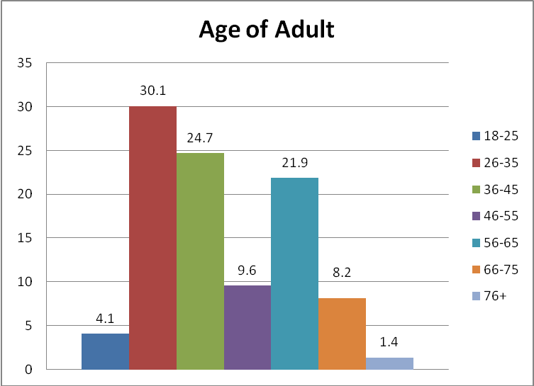
Just over half of respondents (54.8%, n=40/73) were between the ages of 26 and 45.

Are you…
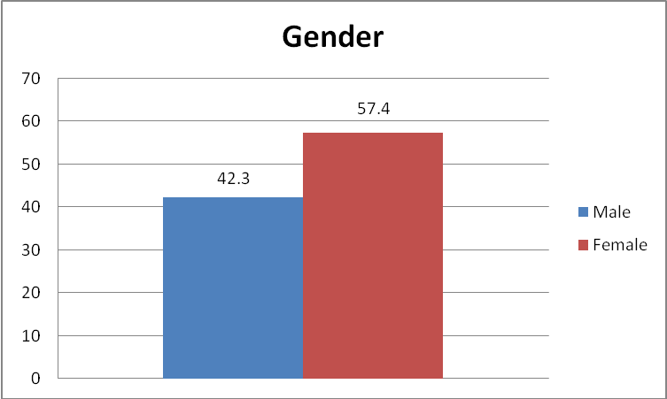
57.4% (n=41/71) of respondents were female.
No one self-identified as GLBTIQ.

Are you a member of this Museum?
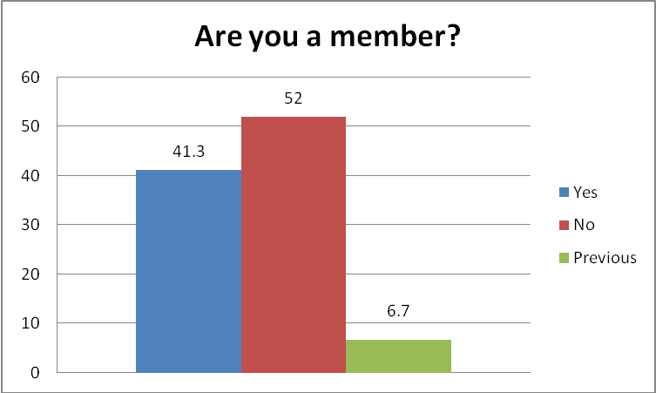
41.3% (n=31/75) of respondents indicated that they were current DMNS Members.

What is your zip code (or country, if non-U.S)? (red indicates a CO zip code)

England | 1
95472 | 1
92563 | 1
81635 | 1
80929 | 1
80919 | 2
80831 | 2
80817 | 1
80602 | 1
80550 | 2
80524 | 1
80516 | 2
80433 | 1
80260 | 2
80249 | 1
80246 | 1
80241 | 2
80239 | 1
80227 | 2
80226 | 1
80223 | 1
80222 | 2
80220 | 2
80219 | 1
80218 | 1
80210 | 1
80209 | 1
80207 | 1
80206 | 4
80134 | 1
80127 | 1
80126 | 1
80124 | 1
80123 | 1
80111 | 1
80031 | 2
80027 | 1
80021 | 1
80020 | 2
80015 | 3
80013 | 2
80012 | 1
80005 | 3
78725 | 1
78256 | 1
71852 | 1
68112 | 1
67330 | 1
66502 | 1
56258 | 1
52411 | 1
44224 | 1
35633 | 1
34205 | 1
22041 | 1
11791 | 1

What is the primary language spoken in your home?
A vast majority of interviewees (97.3%, n=73/75) primarily spoke English at home. 1 respondent indicated that s/he spoke Chinese and 1 reported English/Sign Language as their primary language.

What is your ethnic background or heritage? (Check as many as apply.)
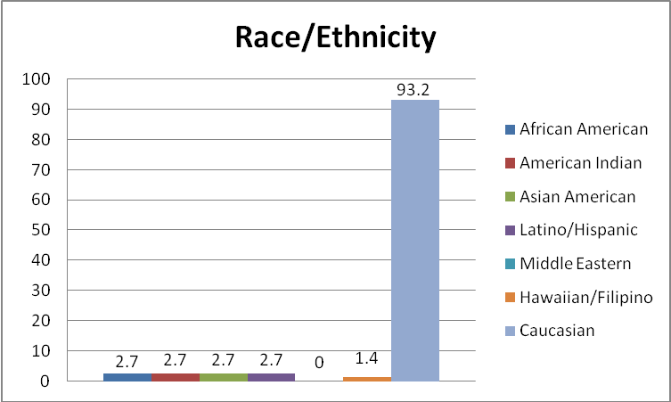

Appendix: Instrument
