Life Beyond Earth Exhibition
Maryland Science Center
Summative Evaluation of School Groups and Adult Visitors

Prepared by:

Robert L. Russell
Hannah Russell
Informal Learning Solutions

Kate Haley Goldman
Stephanie Daughtery
Audience Viewpoints Consulting

December 2013

INTRODUCTION
The Life Beyond Earth (LBE) is a new exhibit at the Maryland Science Center (MSC), which opened in November 2012. While relatively small in square-footage, the exhibit is designed to provoke big questions, such as: Are we alone in the Universe? Is there other life on distant planets or moons? How to scientists know? What are they looking for?

Informal Learning Solutions and its subcontractor, Audience Viewpoints Consulting, conducted summative evaluation in 2013 of the Life Beyond Earth Exhibit. Audience Viewpoints was responsible for evaluating student response to the exhibit, with a target audience of students in 4th through 6th grades. Informal Learning Solutions conducted evaluation of weekend, primarily adult visitors response to the exhibit.

Life Beyond Earth was developed through the participation of an Advisory Panel with representatives from The Johns Hopkins University, NASA, The Carnegie Institute of Washington, The Space Telescope Science Institute, the Maryland School for the Blind and Maryland Sea Grant. The material contained in Life Beyond Earth is based upon work supported by NASA under grant award Number NNX10AK15G.

LIFE BEYOND EARTH EXHIBIT
Located on the second level of the building, Life Beyond Earth is part of MSC space and aerospace exhibits housed in the Our Place In Space area of the building. Major sections of the exhibition cover the vastness of the universe, places in the solar system where life could exist, the search for exoplanets, and questions that remain to be answered.

The exhibit includes several iconic elements. A large interactive multitouch table enables visitors to try out five techniques astronomers use to hunt for exoplanets. An orrery with supporting text/graphics shows the planets of our solar system in motion as they orbit the sun. As part of this exhibit, special tactile components – touchable microbes, planet surfaces, and Milky Way galaxy (including the position of our solar system within the galaxy) -- provide accessibility to visitors with vision limitations, and Braille guides are available for use in the exhibit.

Other elements of the 1500 square foot exhibition, which opened November 2, 2012, include a huge mural of the Milky Way that highlights our galaxy’s enormous number of stars and the latest findings about its shape; large images of extreme life with explanatory text; tactile models of extreme life; meteorites on loan from the Smithsonian; videos and large graphics on planets and moons and their potential as contexts for the development of life; and large graphics with supporting text on the field of astrobiology, how scientists search for life beyond the earth, and the search for exoplanets,

The exhibit is supplemented by the companion planetarium show, We Are Aliens, and a free PlanetMania mobile phone app to play while in the exhibit. Using the app, visitors can earn points playing PlanetMania to redeem a discount in the Science Store. App development was made possible thorough funding from the National Science Foundation and exhibit made possible through a NASA education grant. This evaluation focuses entirely on the exhibit components supported by the NASA grant referenced above and does not include the planetarium show and PlanetMania app.

COMPONENTS OF THIS REPORT
This report includes four sections: the Introduction; Student Evaluation; Adult Evaluation; and Summary.

Kate Haley Goldman and Stephanie Daughter of Audience Viewpoints completed the data analysis and authored Study 1: Student Responses to the Life Beyond Earth Exhibit. Robert L. Russell of Informal Learning Solutions completed the data analysis and authored Study 2: Adult Responses to the Life Beyond Earth Exhibit. He also wrote the Conclusions section of the report. Hannah Russell assisted in data collection and analysis.

STUDY 1: Student Responses to the Life Beyond Earth Exhibit

Kate Haley Goldman
Stephanie Daughtery
Audience Viewpoints Consulting

The primary goal of this evaluation was a knowledge-based assessment of the gain in student knowledge based on a visit to the Life Beyond Earth (LBE) exhibition.

The key evaluation questions were designed to find out if student visitors show gains in understanding regarding:

- How extreme life on Earth is relevant for the search for life in our solar system and beyond.
- What scientists know about the requirements for life on other planets and how they search life on other planets.
- What scientists have discovered about exoplanets and how scientists search for them.

OVERVIEW: METHODS & SAMPLE
For the student portion of this evaluation, AVC used two primary methods:
- Focused Observations. Based on the small size of the exhibition, the project team elected not to conduct whole-exhibit timing and tracking in lieu of focused observations on selected exhibition elements. These elements were: Home Galaxy, Solar System Orrery Model, and a multitouch table with a PlanetFinder interactive.

A total of 5 schools were observed over the course of 10 weeks. Schools were contacted in advance, and greeted at the Science Center by AVC data collector Stephanie Daughtery. Ms. Daughtery spoke with the school group briefly, and handed out stickers to the students to wear, so that they could be easily identified while at the exhibit. She also coordinated with the teachers regarding the timing of their visit to Life Beyond Earth within the other activities the school had scheduled at MSC that day.

A total of 81 focused observations were conducted, with roughly one-third at each of three components:
Home Galaxy: 36
Orrery: 34
Multi-touch Table: 27

- Pre-Post Visit Surveys of Students. The primary data source for the bulk of the results presented here are from pre-post surveys. Gathered from 9 schools, every attempt was made to examine change in student’s understanding of and attitudes towards Astrobiology. We contacted schools scheduled to visit the exhibition from March to June 2013 and asked them to survey their students both prior to their visit to the Maryland Science Center and afterwards. As ‘Life Beyond Earth’ might be missed within their overall visit, we asked teachers to ensure their students spent a minimum of 12 minutes within the exhibit area. A total of 556 data points were collected in the pre-post surveys, with 405 individuals from 8 schools having both pre and post-visit (matched) data. For 152 individuals there was no matched data.

Limitations of the Study

While this study employs a pre-post methodology, only a portion of the surveys could be identified as true pre-post. Some teachers did not have their students complete the pre or post-version. Children, who were identified for matching purposes by their teachers and their first name and last initial, at times did not fill out the name portion or were absent for one of the classes in which the surveys were filled out. Most data and interpretations described here were drawn from the matched pre-post data; the unmatched surveys were not included in the percentages or statistical tests here unless directly noted.

Results for Focused Observations

Home Galaxy

As already noted by the MSC staff, the Home Galaxy component is highly attractive to individuals. The vast majority of individuals run their fingers along the tactile galaxy arms. While the stay time is quite quick at this component (many times it was difficult to interview as children had already moved on), interview data suggest that most visitors still understand some of the central ideas of the component. In interviews at the component, we asked students if they knew what the tactile model represented. Of the 36 students interviewed, 28 of them explicitly stated it was the Milky Way. Ten of the students used the word galaxy. When asked if they knew what the orange dot was, 31 of the students stated they did, though only 24 gave an answer such as the Sun, the Earth, or where we are. The other answers included Mars, the Orion Spur, and not sure.

We also asked students if they understood what the “arms” portion of the model were, with interviewers pointing rather than describing them so as not to bias the students. For this question answers varied much more significantly. Approximately one-half of the responses could be considered correct, with one third of those individuals consulting the labels for a response.

Examples of correct student responses:
- These are the Perseus arms, and the Orion arms. Gas in the arms.
- Bands of Stars
- Scutum-Centaurus Arm.
- Stars.
- Stars or other solar systems.
- Galaxies.

Other responses included:
- Stardust swirls.
- Asteroid belt.
- Black holes.
- Meteoroids.
- Planets.
- Clouds of the Milky Way.
- Milky Way.
- Hills?

Table 1: Behaviors at the Home Galaxy Component
 | Number of Students (n=36)
Touches the galaxy spiral | 94% (n=34)
Touches the orange dot | 92% (n=33)
Discusses the texture of the spiral | 44% (n=16)
Discusses the orange dot | 44% (n=16)
Discusses what the model means | 36% (n=13)
Reads or looks at associated wall panel | 25% (n=9)
Emotionally reacts to exhibit: Positive (smiles, laughs) | 25% (n=9)
Calls attention to/points at something on spiral/dot | 14% (n=5)
Watches another visitor do an activity | 8% (n=3)
Explains a concept (facilitate learning) | 6% (n=2)
Reads aloud to another person | 3% (n=1)
Helps/assists/instructs (how to use, do something) | 3% (n=1)
Not focused on exhibit/downtime | 3% (n=1)
Emotionally reacts to exhibit: Negative (frustration, disappointment, etc.) | 0% (n=0)

As noted above, almost all of the students observed touched the component and touched the orange dot. Most had a visible positive reaction, and approximately half the students discussed the texture, the orange dot, and what the model represented. (See Table 1.) Approximately one-third of the individuals noticed the panel behind the model and connected the two elements.

Solar System Orrery

Every single student interviewed understood what the model depicted, but only a few noticed the words ‘habitable zone’ within the model. When interviewers asked and pointed out the words, students commented that the rest of the labeling was much brighter, so they hadn’t noticed that particular element.

Students liked the model, as the movement of the component was strongly appealing. Their comments as to why they liked the orrery included:
- Shows you proportion of planets. How fast planets revolve.
- How they move and the sun. The sun is golden.
- How long it takes to spin around the sun.
- Machinery, It's rotating like the planets actually move.
- I like that Pluto's so tiny. I like that there is text around the dome and how it talks about each planet.
- When the sun makes other planets move.
- The sun because it looks like silver.
- Planets in the middle are moving but the ones on the outside are not moving.
- Shows how planets orbit. I like Neptune.
- How they design it. The words are cool. How many moons each planet has.
- The way it shows the planets' orbits. Tells you how big it is in the diameter and how many miles/km from the sun.

As noted in Table 2 below, most students touched the dome, and more than half discussed the planets and/or their orbits. Many students would volunteer a favorite planet. Approximately half of the students read the text around the periphery.

As noted above, few explicitly noticed the habitable zone. When we asked students what the main point of the display was, only 2 of the 34 referenced the habitable zone, or the search for life-sustaining planets elsewhere. Those two responses were:

- How things revolve around the sun. Shows habitable zone where life can survive. [Researcher asked participant to talk more about the habitable zone.] If the earth became overcrowded, we can go to the planets in the habitable zone.

- All about finding life on other planets. It would be easier to find in our solar system.

Table 2: Behaviors at the Orrery Component
 | Number of Students (n=34)
Touches the dome | 98% (n=33)
Discusses particular planets | 59% (n=20)
Discusses movement of planets | 56% (n=19)
Reads content on perimeter of dome | 41% (n=14)
Calls attention to/ points at something on model | 41% (n=14)
Emotionally reacts to exhibit: Positive (smiles, laughs) | 41% (n=14)
Explains a concept (facilitate learning) | 18% (n=6)
Reads aloud to another person | 6% (n=2)
Watches another visitor do an activity | 6% (n=2)
Not focused on exhibit/downtime | 3% (n=1)
Helps/assists/instructs (how to use, do something) | 0% (n=0)
Emotionally reacts to exhibit: Negative (frustration, disappointment, etc.) | 0% (n=0)

Exoplanet Identification: MultiTouch Table

Of the components in the LBE gallery, the Multitouch table was one of the components that generated a crowd. Students watched one another, asked for help from others, and discussed their successes and failures. For example from our observation notes:
- Participant 1 instructs other participant how to find exoplanets. Claps hands and exclaims, "Yes!" when he finds planet. "You're discovering exoplanets!" "Announce discovery." Another student yelled "I found one!" at the multitouch table.

- Fist Pump when discovered first planet. Both girls are reading then discussing strategies. Let the other girl take a turn, switched who sat. “Okay this is FUN. I want to try a different method.” Girls move onto their third method. First girl takes out notebook and is writing down name of methods. Says “Whenever I go to a museum or science center. I write down things I find out.”

- "I've found 3 planets!" "I like the technology of it." Participant tried each method to find a planet. He read the text after he found a planet.

Others participated as a solo activity:

- Participant 1 was quiet. He didn't engage with the other students. He was intent on trying all the games/methods. He was focused on the content and understand how to find exoplanets using each game. He found exoplanets using each method.

The majority of individuals observed (23 out of 27) were able to find a planet (see Table 3), and in fact approximately half went on to find a planet with a second or third method. Still, not everyone was successful finding a planet.

- Participant does not touch "announce your discovery" button and therefore never finds exoplanets. She moves the view over stars, but did not seem to realize that she was supposed to push the button to see if there was an exoplanet. Participant uses multiple methods, including the astrometry method. Eventually, participant gets bored and stops engaging with multitouch table. She does not talk to the other participant, but glances over to his viewer.

- Participant understood what she was looking for, but didn't press "announce your discovery" button. She used transit method and radial velocity method at the table. Participant did not find an exoplanet because she missed the final step of pressing the button. There was minor fighting over the three viewers and they kept briefly changing hands.

Table 3: Behaviors at the PlanetFinder Component
 | Number of Students (n=27)
Finds a planet | 85% (n=23)
Hands on table | 63% (n=17)
Finds a planet with a different technique | 52% (n=14)
Emotionally reacts to exhibit: Positive (smiles, laughs) | 41% (n=11)
Calls attention to/points at something on model | 30% (n=8)
Explains a concept (facilitate learning) | 30% (n=8)
Watches another visitor do an activity | 26% (n=7)
Reads aloud to another person | 22% (n=6)
Has trouble using the table controls/Planetfinder | 15% (n=4)
Emotionally reacts to exhibit: Negative (frustration, disappointment, etc.) | 11% (n=3)
Not focused on exhibit/downtime | 7% (n=2)
Helps/assists/instructs (how to use, do something) | 4% (n=1)

Students clearly understood the goal of the component and could verbalize it, though the amount of understanding varied. Over one-third (10 of 27) included the method in explaining what they were doing:
- Discovering stars or suns. We are discovering new stars. [The participant looked at viewer and listed different methods] transit, astrometry, radial velocity, coronagraph, and microlensing.
- I am seeing if the angle wobbles. [Participant is referring to the astrometry method, which she was using during observation.]
- Trying to find where it's brighter. [Participant is referring to the transit and radial methods.]
- Discover heat signatures.
- Trying to find which planet is brighter or dimmer.
- Find sun. Make solar eclipses.
- To see if a star is bright or dim.
- Using the transit method to discover an exoplanet.
- Find exoplanets. This was the easy method, if you see something revolving around it it's an exoplanet. The other method was harder.
- Study the different methods of finding exoplanets in our solar system and elsewhere.

Eleven interviewees described how they were looking for planets. Seven individuals used the word exoplanets in describing what they were doing. While some individuals were less articulate than others, the basic concept of using multiple techniques other than direct observation to find planets appeared to be clear for nearly all participants. When asked how they did it, students could describe different methods.

- [Shows how to use microlensing method.] You’re looking for star to get brighter, then there's a planet.
- “It was really easy. First it told you how to works on the screen and they give you an example then click a button. If the pattern you're looking for happens when you center it on a star, it tells you found on, which satellite found it.”

Twenty of the students (out of 27) stated this was the first multitouch table they had seen.

Student Memories of the Visit
We asked students what their favorite part of the exhibition was, and coded their open-ended responses. The post-visit survey included pictures of some of the exhibit elements in an attempt to prompt them to think of the correct area of the Science Center. Despite that support, many of the responses were difficult to attribute to a particular component, or even area of the science center. Nonetheless, most students mentioned some form of the content matter, either a specific exhibit element or more general content matter. Their answers were quite general and hard to decipher ranging from: -- “the Ubuals [sic] because they came to life inside the dome” – to -- “My favorite part was seeing the planets and some hands on activity because you may learn many new facts that you did not know at all.”

When students did mention a specific exhibit element, the Orrery (15.7%) was the most likely to be mentioned, followed closely by the Touchtable PlanetFinder (14.9%). It is highly possible that even more individuals mentioned the Orrery or the PlanetFinder, but we were unable to decipher their answers.

Table 4: Student Favorite Aspects of Life Beyond Earth (n=396)
Exhibit Element | Percent
Space-related, unspecific to component | 28.3% (n=112)
Orrery | 15.7% (n=62)
Planet Finder | 14.9% (n=59)
Planetarium | 9.6% (n=38)
Unknown/elsewhere in the Science Center | 7.1% (n=28)
I don't know | 5.3% (n=21)
Black holes/Black lights | 4.3% (n=17)
Home Glaaxy | 3.8% (n=15)
Hands-on elements | 3.8% (n=15)
IMAX | 2.8% (n=11)
The "game" | 2.5% (n=10)
Everything | 2.0% (n=8)
Total | 100%

Results for Student Survey: Vocabulary

As part of the evaluation, we asked several vocabulary questions both in the pre-test and in the post-test, to determine the extent of knowledge of the proper terminology. Prior to their visit to LBE, over 40% of students stated the correct term for planets outside our solar system was “Astroplanet.” Approximately one-third (38.6%) had the correct term, Exoplanet. (See Tables 5-7.) After their visit, students were significantly more likely to know the correct term for extra-solar planets, with 52% of the students choosing the term Exoplanet. This answer was found highly significant via the McNemar’s Test, at a p-value of .000.

Table 5: Term for Planet Outside Our Solar System
 | Pre-Visit | Post-Visit
Astroplanet | 40.6% (n=206) | 11.5% (n=48)
Rogue Planet | 16.5% (n=84) | 25.1%(n=105)
Goldilocks Planet | 4.3% (n=22) | 11.5% (n=48)
Exoplanet | 38.6% (n=196) | 52.0% (n=218)
Total | 100% (n=508) | 100% (n=0)

Table 6: Pre-Visit Term for Planet Outside Our Solar System By Grade
 | 4th Grade | 5th Grade | 6th Grade
Astroplanet | 37.3% | 43.6% | 39.7%
Rogue Planet | 19.1% | 14.9% | 16.5%
Goldilocks Planet | 4.8% | 5.3% | 3.1%
Exoplanet | 38.9% | 36.2% | 40.7%

Table 7: Post-Visit Term for Planet Outside Our Solar System By Grade
 | 4th Grade | 5th Grade | 6th Grade
Astroplanet | 14.0% | 10.3% | 10.8%
Rogue Planet | 21.1% | 26.3% | 26.9%
Goldilocks Planet | 11.4% | 12.6% | 10.0%
Exoplanet | 53.5% | 50.9% | 52.3%

Students were more likely to know the correct term for the field of study of life in space, Astrobiology, prior to visiting the LBE exhibit. For that question, we gave three similar, plausible terms (Extraterrestrial biology, Alien biology, and Exobiology) in addition to the correct answer. Nearly half (46.7%) correctly identified that term in the pre-visit survey. (See Table 8.) The second most popular option was Extraterrestrial biology. There was a small gain in the number of students who could correctly name the appropriate scientific field after their visit, to just over half of the students who could name the appropriate term. This pre-post difference was significant in the McNemar test at a p-value of .009.

Table 8: Term for Scientific Field that Studies Life in Space
 | Pre-Visit | Post-Visit
Astrobiology | 46.7% (N=240) | 52.7% (n=221)
Extraterrestrial Biology | 29.0% (n=149) | 20.3% (n=85)
Alien Biology | 9.7% (n=50) | 9.6% (n=40)
Exobiology | 14.6% (n=75) | 17.4% (n=73)
Total | 100% (n=514) | 100% (n=419)

Table 9: Pre-Visit Term for Scientific Field that Studies Life in Space
 | 4th Grade | 5th Grade | 6th Grade
Astrobiology | 44.1% | 46.8% | 48.2%
Extraterrestrial Biology | 22.8% | 34.6% | 27.6%
Alien Biology | 13.4% | 5.9% | 11.1%
Exobiology | 19.7% | 12.8% | 13.1%

Table 10: Post-Visit Term for Scientific Field that Studies Life in Space
 | 4th Grade | 5th Grade | 6th Grade
Astrobiology | 48.3% | 49.7% | 60.5%
Extraterrestrial Biology | 29.0% | 21.6% | 11.2%
Alien Biology | 8.8% | 8.8% | 11.2%
Exobiology | 14.0% | 19.9% | 17.2%

Results for Student Survey: Self-Assessment of Knowledge
Early in the post-visit survey, we asked students whether anything about the exhibit surprised them. We often use this question as a way to measure whether they have learned from the exhibit without using the word “learn”. In this case, 52% of the students stated that there was something within the exhibit that surprised them. While many of those that stated yes were actually referring to other areas of the science center (“The surprising thing is how tall is the dinsor [sic] bones.”) others were either indeterminate (“The moive [sic] surprise me.”). Finally, some did comment specifically on space-related content, such as the individuals who were surprised by water on Mars. "That Mars has frosen [sic] water."

While still believing themselves far from experts, students believed that their knowledge had changed after visiting LBE. They rated themselves three-quarters of a point higher after visiting the exhibit than beforehand. After their visit to LBE, students were more likely to rate themselves slightly above the median. This difference was highly significant in a paired T-test at α < .000.

Table 11: On a scale of 1-7, with 7 being ‘I’m an Expert’, and 1 being ‘I don’t know much at all’, how much do you know about the search for life on other planets?
 | 4th Grade | 5th Grade | 6th Grade | Overall Average
Pre | 3.33 | 3.04 | 3.12 | 3.14
Post | 4.19 | 3.67 | 3.97 | 3.90
Calculated Change between Pre- to Post- | 0.95 | 0.65 | 0.73 | 0.75

Results for Student survey: Life on Other Planets

One of our first questions on the pre-post visit survey was to determine what students already understood about life on other planets prior to their visit. Approximately one-quarter of the students erroneously believed that life elsewhere had already been discovered. (See Table 8.) Another 30% were uncertain whether or not life had been discovered. This did not vary widely by grade. (See Table 12.) After their visit to the LBE, students were slightly more likely to have the correct answer, by a narrow margin. Slightly fewer individuals were certain that life had already been found on other planets. In addition, the number of individuals uncertain about whether life has been found or not also increased. This difference was carried through each of the grades tested. However, the difference was not found to be statistically significant when examined using the McNemar test.

Table 12: Understanding of Whether Life on Other Planets Has Been Found
 | Pre-Visit | Post-Visit
Scientists have already found life on other planets | 24.1% (n=126) | 21.9% (n=93)
Scientists have not already found life on other planets | 45.0% (n-235) | 49.4% (n=212)
I’m not sure | 30.8% (n=161) | 28.9% (n=124)

Table 13: Pre-Visit Understanding of Whether Life on Other Planets Has Been Found By Grade
 | 4th Grade | 5th Grade | 6th Grade
Scientists have already found life on other planets | 25.2% | 25.1% | 22.6%
Scientists have not already found life on other planets | 47.2% | 41.9% | 46.6%
I’m not sure | 27.6% | 33.0% | 30.9%

Table 14: Post-Visit Understanding of Whether Life on Other Planets Has Been Found By Grade
 | 4th Grade | 5th Grade | 6th Grade
Scientists have already found life on other planets | 12.6% | 14.8% | 18.3%
Scientists have not already found life on other planets | 40.2% | 35.5% | 23.9%
I’m not sure | 30.7% | 34.4% | 31.5%

To gauge the students’ understanding about the current search for exoplanets, we asked them to estimate how many planets had been discovered in other solar systems, giving them the options of none, five, around 500 (the correct answer) and around 100,000. Prior to visiting LBE, approximately one-third of the students (32.4%) had the correct answer. As you can see in Table 13, the percentage of individuals with the correct answer went up, and did so across all grades. This answer was found highly significant, at a p-value of .000.

Table 15: How many Exoplanets have been found?
 | Pre-Visit | Post-Visit
None | 15.6% (n=80) | 12.6% (n=54)
Five | 32.7% (n=165) | 22.0% (n=94)
Around 500 | 32.4% (n=166) | 40.4% (n=173)
Around 100,000 | 19.9% (n=102) | 25.0% (n=107)
Total | 100% (n=513) | 100% (n=428)

Table 16: Pre-Visit: How many Exoplanets have been found by grade
 | 4th Grade | 5th Grade | 6th Grade
None | 12.6% | 14.8% | 18.3%
Five | 40.2% | 35.5% | 23.8%
Around 500 | 30.7% | 34.4% | 31.5%
Around 100,000 | 16.5% | 15.3% | 26.4%

Table 17: Post-Visit: How many Exoplanets have been found by grade
 | 4th Grade | 5th Grade | 6th Grade
None | 13.0% | 11.7% | 13.4%
Five | 27.0% | 20.1% | 20.2%
Around 500 | 46.1% | 40.8% | 35.1%
Around 100,000 | 13.9% | 27.4% | 31.3%

We also asked students to describe, in their own words, how scientists found these planets. We coded their responses into numerous categories. At times, the spelling was too unclear to discern their meaning, but the majority of the time we were able to piece together the flow. Students at this age often struggle to express themselves appropriately, and sometimes have a concept but lack the vocabulary. One example of this is that multiple students (11 individuals in the pre-study) stated that scientists use microscopes to find exoplanets. There are two possibilities here. First, they may have simply confused the word microscope with the word telescope. Secondly, they may be thinking of the concept that scientists study microscopic life forms, especially extreme ones, in order to better understand the conditions and potential life forms that exist on exoplanets.

After their visit, students were more likely to have an idea of how scientists find planets, as the number of those responding they didn’t know decreased. Students were also more likely to mention telescopes, rovers, probes, robots and drones after their visit. They were less likely to mention satellites, rocket ships, astronaut visits, and technology in general. (See Table 18.)

Table 18: How do scientists look for other planets?
Method of Finding Exoplanets | Pre | Post
Telescopes/big binoculars (1) | 26.3% | 30.7%
Hubble Telescope (2) | 2.6% | 2.4%
Satellites (3) | 15.3% | 12.9%
Rocket ships/spaceships/rockets (6) | 11.3% | 5.2%
Rovers (7) | 9.1% | 12.9%
Probes/robots/droids/drones (8&9) | 4.7% | 11.6%
Cameras/take pictures (5) | 4.7% | 3.4%
Computers/electronics/special equipment/technology (11) | 4.6% | 3.4%
Sound rays/sonar/radio waves/radar/solar panels (13 & 12) | 1.9% | 2.6%
Astronauts visit (10) | 1.6% | 0.6%
Microscope (4) | 1.6% | 2.0%
Goldilocks method/measure light wobble | 0.4% | 4.4%
I don’t know (16) | 8.2% | 4.0%
Missing Data (0) | 2.6% | 3.8%

To explore how well students understood the search for exoplanets, we asked them why it was so difficult to find planets like Earth. While the question allows a wide range of responses, our intent was to give students an opportunity to explain the unique conditions on earth that support life. These include the habitable zone, the range of distance from the sun that allows a planet to receive enough heat and light, without too much. Other conditions, such as the amount and type of atmosphere and resources, are also critical. This was an open-ended question, allowing them to express directly why it is so hard to locate life-sustaining planets like Earth.

Students were fairly certain, both prior to the visit and afterwards that Earth possesses specific characteristics supporting life, and finding similar planets was difficult. This was the most common answer, with 35% of the pre-visit students and 39% of the post-visit students giving some variation of this particular response. As Table 18 demonstrates, most students have some conception that there are multiple resources needed to support life, and that these resources are relatively rare.

Table 19: Why is it hard to find planets that are like Earth?
 | Pre | Post
Earth has the right conditions (atmosphere, oxygen, water, temperature, plants, gravity, resources, etc) | 34.8% | 39.0%
Other planets don’t have living things (people, animals, plants) like Earth | 17.2% | 17.0%
Earth is different/rare/unique/one of a kind | 5.0% | 8.7%
Earth is the right distance from the sun | 8.6% | 6.9%
Other planets are far away | 8.2% | 6.7%
The planets must be in the habitable/goldilocks zone | 0.0% | 1.4%
Other | 15.9% | 13.1%
I don’t know | 4.6% | 4.6%
Missing Data | 5.7% | 2.8%

Examples of students’ responses listing conditions right for life include:
- Because they have to figure out whether there is oxegoen [sic] or not. –5th grade
- You need to have exactly the right temperature, and conditions that will support living things. –5th grade
- It is hard because other planets don't have the same oxegen[sic], water, food and other things that human need. –5th grade
- Few planets have oxygen in their atmosphere. –6th grade,
- Because other planets need to have the perfect atmosphere and living conditions. –6th grade

Examples of students’ responses stating that a planet would need to be at the right distance from the sun, like Earth:
- Because Earth is the perfect distants away from the sun. - 5th grade
- It's hard because they have to be the right distance from sun. - 5th grade
- Because exo-planets might be closer or farther from there [sic] sun making the planet uninhabitable. –5th grade
- Some are far away from are [sic] star (sun) which make them cold. Some are close to the star (sun) which makes them hot. –5th grade
- Because only earth is placed at the right place to get the right amout a sun. –5th grade
- Because there are planets that are either to close to the sun or to far frome the. And if it's to close everything would burn, but if to far everything would freeze. –5th grade
- Most of them are farther away from the sun. (hot or cold). - 5th grade

Examples of students’ responses detailing the uniqueness and rarity of Earth:
- Earth is one of a kind. –4th grade
- because earth is like one in a million. –4th grade
- There is no planets like Earth. –6th grade
- Because every planet didn't form the same way Earth did. –6th grade
- Its [sic] hard because most planets arent [sic] exactly like earth. –6th grade
- because they are Rare. –6th grade

One of the key exhibit elements was the concept that astrobiology involves the study of extreme life forms on Earth so as to better outline the possibilities for life elsewhere. We asked students to describe, in their own words, why scientists study extreme life. While approximately one-third of students gave in specific or at times erroneous answers, many individuals had some sense of how the study of extreme life applied to astrobiology. Approximately 15-20% of the students couldn’t answer the question, simply writing “I don’t know” or “I have no clue”. There was a decrease in the number of students who couldn’t answer the question between the pre-visit questionnaire and the post-visit questionnaire. (See Table 20.)

Table 20: Why do scientists study extreme life?
 | Pre | Post
Comparison between conditions on Earth and other planets/ studying extreme life on Earth helps us look for life on other planets/adaptions | 28.7% | 27.3%
Research/expand knowledge/help us know what to look for | 16.6% | 20.6%
Other | 27.9% | 31.4%
I don’t know | 20.1% | 14.2%
Missing Data | 6.7% | 6.4%

Nearly 30% of the respondents made some sort of comparison between extreme life on earth and finding life on other planets. Their responses included:

- To see if there is life on other planets. –4th grade
- So we know an example of what type of life forms we could find. –4th grade
- If there are living things in the dessert [sic] there might be in other plantes. [sic] –4th grade
- Maybe those life forms can live on other planets. –6th grade
- The more life forms that are found that can cope with extreme temperatures/climate, the more possibility there is that organisms can survive on the extreme planets such as Venus. –6th grade
- It might help them have an idea of what would be on other planets in outter [sic] space. –6th grade

Others gave more general answers which may indicate an understanding that they are not yet expressing fully. These answers, comprising 21% of the post-visit responses, mostly stated “To know what to look for.” Examples include:

- Because then it might help know what to look for. –5th grade
- I think studying extreme on Earth helps scientists know how they look or something. –5th grade
- It helps them because they will learn some thing they didn't know. –5th grade
- So they can differentiate planets and also share their research and results, so the world can know more. –6th grade
- So they can learn more so they know what to use when they are searching for stuff. –6th grade

Summary of Findings For Students

Observations

This exhibit very much embodies the concept of hands-on. Students touched each of the elements in the exhibit under observation. Some interactions, like at the Home Galaxy station, were fleeting. Nonetheless most students touched the tactile components, and had some understanding of what the component was representing. The tactile nature of the component supported conversation between the students.

Likewise, students were fascinated with the orrery, and while direct touching was not possible, they embraced the dome and entered into conversations regarding their favorite planets and the movement of the solar system. Few students noticed the habitable zone language, and we would suggest brightened the text to more neon colors to draw attention to this element.

The multitouch table interactive on the different methods scientists use to find planets was highly successful, with students engaging in multiple methods of finding exoplanets, and accurately being able to describe both the techniques and what they were searching for. While not all students spent a significant amount of time at the table, those that did employed correct vocabulary in describing their action, suggesting that the interactive helped support the deeper exploration of content. Despite the fact that few students had interacted with a multitouch table previously, most of the conversation focused on content rather than the novelty of the technology.

Overall, the evidence shows that students learned vocabulary and content knowledge within the exhibit, despite the short stay times.

Pre-Post Comparisons of Student Knowledge

Overall, students showed incremental but significant improvement in vocabulary regarding astrobiology and exoplanets. Prior to their visit to LBE, they rated their knowledge slightly below median on a 1-7 scale. After their visit, they clearly felt their knowledge had improved, and they rated it significantly higher. Post-visit, students were only slightly more likely to state that life had not yet been found on earth, though as only half were certain of this, there is still room for improvement in this marker. Students showed significant gains in knowledge in the correct number of exoplanets found and how scientists identify these planets. Students both before and after their visit were able to make connections between the study of extreme life on Earth and the search for life on other planets.

Overall, exhibit visitation fosters a discernable increase in knowledge regarding astrobiology and exoplanets in the target audience of late elementary and early middle school students.

STUDY 2: Adult Responses to the Life Beyond Earth Exhibit

Robert L. Rusell
Hannah Russell
Informal Learning Solutions

The primary goal of this evaluation was a knowledge-based assessment of the gain in adult knowledge based on a visit to the Life Beyond Earth (LBE) exhibition.

The key evaluation questions were designed to find out if adult visitors show gains in understanding regarding:

- How extreme life on Earth is relevant for the search for life in our solar system and beyond.
- What scientists know about the requirements for life on other planets and how they search for life on other planets.
- What scientists have discovered about exoplanets and how scientists search for them.

OVERVIEW: METHODS & SAMPLE

For the adult portion of this evaluation, ILS used two primary methods:

1. Observations and interviews with individual adult visitors and family groups.

Adults were observed unobtrusively as they viewed and interacted with exhibits in the gallery. Twenty groups were observed. The groups numbered from 2-5 members. Twelve of the groups included children, with the ages of children in different groups ranging from about 4 years through middle school. Visitors’ path through the exhibit and their stops were recorded. Visitors who were observed received no incentive for participation.

2. Pre-Post Visit Surveys. Surveys were collected from adults (18 years and older) before and after their visit to the exhibit. The survey instruments that were used were the same as those used in the student study, with two additional two additional items:
- Please list up to 3 new ideas or concepts you learned from the exhibit.
- Please list up to 3 things about “life beyond earth” you would like to learn more about.

(See Appendix for the survey forms.) Adult visitors were approached as they waited in line to purchase admission tickets or to obtain entrance using their membership. They were told that the Maryland Science Center had installed a new exhibit and was obtaining information about the success of the exhibit through visitor surveys. They were then invited to take part in the evaluation by filling out a survey before and another immediately after they visited the “Life Beyond Earth” exhibit. One ILS representative recruited participants and another provided post-visit surveys and payment to participants. Participants were told that filling out the two survey would take a total of about 15 minutes, that they should spend at least 10 minutes in the exhibit, and were offered an incentive of $20, paid upon completion of the surveys.

A total of 102 adults agreed to participate, but four failed to fill out the post-visit survey, resulting in a sample of 98 adults who completed both surveys. About 20% of those who were invited to participate declined, most citing their limited time as the reason for not participating. Of the 98 adults who agreed to participate, 42% were male and 58% were female; they had an average age of 34.6 years. The surveys were collected on five Saturday or Sunday afternoons during September and October, 2013.

LIMITATIONS OF THE STUDY

For the pre-post visit component of the study, participants filled out the pre-visit survey at the beginning of their visit and the post-survey during their overall visit, but immediately after visiting the LBE exhibit. The pre-visit survey may have attenuated their attention to the specific topics in the survey, resulting in higher levels of recall of exhibit content than might have resulted if they had not filled out the pre-visit survey. Participants were asked to spend at least 10 minutes in the exhibit, which appears to be longer than typical visits to the exhibit.

Results for Observations of Adult Visitors

Only a minority of MSC visitors who enter the exhibit gallery stop to experience the exhibits. While these visitors were not surveyed to determine their reasons for passing through, it is likely that they already had an “agenda.” The “Life Beyond Earth” is a relatively small gallery and serves, in part, as a passageway and queuing area for those who plan on attending a planetarium show or who are on their way to another area of MSC. Only visitors who spent a minimum of at least two minutes were observed.

The following generalizations should be taken with caution, since the number of groups observed is relatively small and a standardized methodology was not used to analyze the observations. Below are several examples of how different groups experienced the exhibit.

Thirty groups were observed. The following generalizations characterize the behavior of these groups in the exhibit:

There is no standard path through the exhibit. The exhibit can be entered from either end of the space. Visitors typically browsed through or interacted with some of the exhibits, typically stopping at interactives for the longest periods of time.

Example 1: Two adults entered the exhibit with two children who appeared to be 7 or 8 years old. The whole group first went to the touchable extremophiles and touched the models; the adults read text. One child and then another split off to look at the orrery; one came back to bring back an adult to look at the orrery with them. The other child then went to look at and touch the Milky Way model. The children and adults talked about the exhibits when they were together. The group then left the gallery, after spending about 4 minutes in the exhibit.

Example 2: Two adults, who appeared to be in their twenties, first went to the touchable graphics and related graphics, lingering there, touching the models, reading the graphics, and talking. They then moved on to the video station, where they briefly watched one of the videos, moving on to the orrery, where they spent the most time of any of the exhibit components they viewed. They read available text and conversed. They then split up, one going to look at images of exoplanets and the other returned to the orrery. They then left the gallery, after spending about 6 minutes in the gallery.

Example 3: A woman and an elementary-aged girl entered the exhibit and first sat down at the interactive multitouch table that shows techniques for finding exoplanets. They interacted with the table for about 4 minutes, then went immediately to the orrery, where they spent about 3 minutes looking at the model, with the mother pointing and talking about the model. The two thus spent about 7 minutes in the exhibit.

Example 4: A woman and two boys who appeared to be 8-9 years old first went to the touchable universe and the nearby flip labels. They touched the planets and the mother read the flip labels as they continued to interact with this part of the exhibit. After spending over two minutes, they moved on to the interactive table presenting techniques for finding exoplanets. They spent the next several minutes at the multitouch table, apparently learning how to use the “planet finder” and then having a “competition” to find planets. They showed the woman, who had been observing, how to use the exhibit. The group spent about five minutes in the exhibit.

A qualitative summary of what appear to be typical behavior patterns in the exhibit area is provided below:

1. Most visitors spend short periods of time in the exhibit, typically ranging from 2 minutes to 7 or 8 minutes. A majority of visitors appear to pass through the gallery en route to a scheduled planetarium show or other exhibit area and do not linger at the exhibit. (These visitors do not appear to be choosing to not visit the exhibit; they simply have another agenda.)

2. Groups often broke up; individuals or pairs of visitors (e.g., adult and child, two adults) pursued exhibits that attracted their interest. Weekend visitors typically come in small groups from 2 to 4 or 5 people. Shortly after entering the exhibit, members of a group would often split up to pursue an exhibit element of particular interest to them.

3. Children often direct the attention of accompanying adults (who, in many case, are presumably parents or grandparents) to interactives or other exhibits they find particularly interesting. For example, children often “instructed” adults in how to use the interactive table.

4. There are often conversations that focus on exhibit elements. Adults often read exhibit text and direct children’s attention to specific exhibit elements that may relate to the text. For example, at the orrery, adults may point out the location of earth or other planets and try to explain what is going on.

5. A majority of visitors browse through the exhibit, finding one or two exhibit elements that take up most of their time, and ignoring or only giving brief attention to other exhibit elements.

6. Interactives, especially the interactive table and the orrery, generally attract and held visitors’ attention more than static exhibit elements. These exhibit elements may attractive participation because they maybe the most visually noticeable, since they were positioned as freestanding elements in the middle of the gallery. They may also attract attention because they show constant movement (e.g., the planets are orbiting around the sun in the orrery; planet finders and shooting stars are always visible when the interactive table is not in active use).

7. Older adults appear to read exhibit text to a greater extent than younger visitors. Many adult visitors appeared to experience the exhibit more like an art gallery, systematically looking at each exhibit element, reading text, viewing images, and touching or using exhibit elements.

Results for Adult Survey: Vocabulary

Participants were asked two vocabulary questions about their knowledge of standard terminology used by scientists who are studying astrobiology. As Table 1 shows, a majority (60%) of participants already knew the standard term (exoplanet) for a planet outside our solar system, but this increased to 86% in the post-visit survey. Likewise, a majority (56%) also knew the standard term for the field of science that studies life in space (astrobiology), which increased to 86% in the post-visit survey. Both results are highly significant via the McNemar Test, at a p-value of .000.

Table 1: Term for Planet Outside Our Solar System (N=98)
 | Pre-Visit | Post-Visit
Astroplanet | 27% | 14%
Rogue Planet | 13% | 0.0%
Goldilocks Planet | 0.0% | 0.0%
Exoplanet | 60% | 86%

Table 2: Term for Scientific Field that Studies Life in Space (N=98)
 | Pre-Visit | Post-Visit
Astrobiology | 56% | 86%
Extraterrestrial Biology | 20% | 14%
Alien Biology | 1% | 0%
Exobiology | 23% | 22%

Results for Adult Survey: Self-Assessment of Knowledge
On a scale of 1-7, with 7 being ‘I’m an Expert’, and 1 being ‘I don’t know much at all’, how much do you know about the search for life on other planets?,” adults rated themselves an average of 1.9 on the pre-test and 3.2 on the post-test. This result was found to be highly significant in a paired T-test at α < .000. This positive increase in self-assessed knowledge regarding the search for extraterrestrial life is consistent with the findings from objective items showing knowledge gains in vocabulary and in self-reports of knowledge gains in the exhibit.

Results for Adult Survey: Life on other Planets

When asked whether or not life on other planets had been found (Table 3), less than half (42%) responded that life had not been found on other planets, which increased to a great majority (62%) in the post-visit survey, which is a highly significant result via the McNemar Test, at a p-value of .000.

Table 3: Understanding of Whether Life on Other Planets Has Been Found (N=98)
 | Pre-Visit | Post-Visit
Scientists have already found life on other planets | 38% | 22%
Scientists have not already found life on other planets | 42% | 62%
I’m not sure | 20% | 16%

About half of participants responded that “around 500” exoplanets had been discovered in both the pre- and post-visit surveys (Table 4). This result was not significant. One reason for this result may be the varying numbers of exoplanets reported in the news media as discovered or confirmed.

Table 4: How many Exoplanets have been found? (N=98)
 | Pre-Visit | Post-Visit
None | 6% | 13%
Five | 13% | 22%
Around 500 | 50% | 55%
Around 100,000 | 31% | 41%

In an open-ended question, participants were asked what techniques scientists use to find exoplanets (Table 5). Their responses were examined and then categorized. In both pre- and post-visit surveys, about half responded with “telescopes” and about one-fifth responded with “satellites.” Both are used to collect data to identify exoplanets; however these respondents did not provide any details on how telescopes or satellites were used. Only a small percentage (7%) of participants identified the actual techniques used to find exoplanets, however, this increased to 29% in the post-visit survey.

Some examples of the specific techniques that participants described include:

- Gravitational impact of planet on star
- The light from the star dims when a planet passes in front
- Microlensing
- Star wobble
- Indirect methods: transit method, chronography, microlensing, spectrography

Table 5: What techniques do scientists use to find planets outside our solar system? (N=98)
Method of Finding Exoplanets | Pre | Post-Visit
Telescopes (including Hubble) | 51% | 53%
Satellites | 21% | 19%
Specific method (as identified in exhibit) | 7% | 29%
Rover | 13% | 3%
Humans in space | 7% | 1%
Not applicable (don’t know, no answer, irrelevant answer) | 12% | 14%
Note: The total for each column adds to greater than 100%. Some respondents identified more than one technique or method.

Participants were asked, in a free-response question, why it is difficult to find exoplanets. Their responses, both pre- and post-visit, were categorized (Table 6). Their responses shifted somewhat from pre- to post-visit, however, however these changes showed no apparent pattern that could be attributed to exhibit experiences.

Table 6: Why is it hard to find planets that are like Earth? (N-98)
 | Pre-Visit | Post-Visit
Other planets are so far away, dim, etc. | 23% | 36%
Other planets don’t have the conditions to support life | 27% | 17%
Earth has unique conditions (e.g., distance from the sun, air, etc.) | 22% | 32%
Not applicable (don’t know, no data, irrelevant answer) | 28% | 15%

When asked how studying extreme life on earth helps in the search for life on other planets (Table 7), a majority in both pre-and post-visit surveys identified relevant reasons (e.g., helps scientists compare earth and other planets). Although there were some shifts in proportions of responses for specific categories, these shifts were not large, so it is difficult to attribute these changes to the exhibit.

Table 7: How does studying extreme life on Earth help scientists look for life on other planets? (N=98)
 | Pre-Visit | Post-Visit
Comparison between conditions on Earth and other planets | 37% | 36%
Shows the types of environments that can support life | 25% | 20%
Helps us know what to look for on other planets | 12% | 27%
Not applicable (don’t know, no data, irrelevant answer) | 29% | 17%

Results for Adult Survey: Reactions to the Exhibit

In an open-ended question, participants were asked what their favorite part of the exhibit was. Two-fifths (42%) of the participants identified a specific exhibit element (i.e., the interactive table, solar system model, videos). Nearly half identified the opportunity to learn about a topic (i.e., miscellaneous topics, extremophiles, life on other planets).

Table 8: What was your favorite part of the Life Beyond Exhibit? (N=98)
Miscellaneous information or topics presented in exhibit (e.g., moons, planets, how scientists work, etc.) | 26%
Interactive table (techniques for finding exoplanets) | 18%
Learning about extremophiles | 13%
Interactives (touchable items, such as extreme life, galaxy) | 9%
Solar system model | 8%
Videos | 8%
Learning about life on other planets | 7%
Not applicable (don’t know, no data, irrelevant answer) | 9%

When asked about what they found surprising in the exhibit, two-thirds (67%) of participants identified specific topics or concepts. The relatively large proportion (33%) of “miscellaneous” responses illustrates the widely varying individual experiences and interests of participants.

Table 9: Did anything in the exhibit surprise you? (N=98)
Miscellaneous learning about topics presented in exhibit (e.g., moons, planets, how scientists work, etc.) | 33%
The number of exoplanets | 17%
Extremeophiles | 10%
Ways to find exoplanets | 7%
Not applicable (don’t know, no data, irrelevant answer) | 31%

Results for Adult Survey: Self-reported Learning
In a free response question, participants (N=98) were asked to list up to three new ideas or concepts they learned in the exhibit. The exhibit was rich in content and covered several broad exhibit themes in some depth, including techniques scientists use to find exoplanets, extremophiles, planets and moons in our solar system (and their potential as contexts for life), and general space science.

The ideas or concepts listed by respondents were reviewed regarding their relevance in two respects: was the idea or topic clearly described and was it included in the exhibit. Based on this review, most (92%) participants listed one or more topics they learned about and over two-thirds (73%) named three. While they were not asked to provide a full explanation of the topics or concepts, the results show that a great majority of participants reported that they learned multiple concepts from the exhibit.

Several themes were mentioned most frequently by participants. These are listed below, including the proportion of participants who identified the new ideas or concepts and some examples of responses:

Extreme life on earth and/or how extreme life on earth guides the search for life on other planets (38%)

- Using extreme life conditions on earth to study other planets
- Some new animals that live on extreme places
- Examples of extreme life on earth
- Scientists study extreme life on Earth to learn about possible life on other planets
- Microbes may exist on other planets

How exoplanets are discovered (32%)

- Spectrum variation method to find exoplanets
- Microlensing
- The methods for detecting exoplanets
- How planets are discovered
- Using different filters on a telescope

Moons orbiting other planets (29%)

- How there could be life forms on the planet’s different moons
- Moons and how the moons are formed
- Titan has methane on the surface
- One of Saturn’s moons could potentially have sulfur-based life
- There are moons with ice, maybe water

Space science (25%)

- The number of planets outside our solar system
- Our place in the galaxy
- There are millions of galaxies
- Mercury’s year is shorter than its day
- How small we are compared to the universe

Conditions for life to exist on planets (22%)

- Asteroids colliding with earth brought just the right amount of water
- Images from Mars show the existence of water
- How many planets have water
- Astrobiology, studying space and life
- The habitable zone

Results for Adult Survey: What More Would You Like to Learn About
Participants (N=98) were asked to list up to three topics in the exhibit they would like to learn more about. Most (95%) of participants identified one or more topics or question, which ranged over a wide variety of subject matter introduced in the exhibit. There were several broad topics that were mentioned most frequently. These categories and some examples of participant responses are provided below (rephrased as questions):

Life on Other Planets

- How can you determine if life exists on another planet?
- What would be the most accurate way to find life in outer space?
- What are the closest things to actual life discovered?
- Have some of these exoplanets had life on them before?
- What kinds of fossils, if any, have been found on other planets?
- How far out in our solar system have we found life?
- What have we found out so far?
- How did life develop on earth?
- Does Mars have life?
- How habitable are Mars and Europa?
- What fossils, if any, have been found on other planets?

Exoplanets

- Where is the nearest exoplanet to possibly contain life?
- What are the conditions like on some of the exoplanets discovered?
- How far away are some of the exoplanets?
- What are different conditions on planets that are considered habitable?
- Does NASA have any plans for checking any planets for microorganisms?
- What are the characteristics of other planets?
- How far away have planets been discovered?
- Which of the exoplanets we have discovered is most likely to have life?
- What are the criteria for supporting human life on another planet?
- Can food be grown on other planets?

Extreme Life

- What are some more exotic creatures found on earth?
- What kind of organisms have we not found?
- How do extremophiles actually deal with the conditions they live in?
- Can we actually collect extremophiles?
- Can extremophiles be parasitic or beneficial to health?

Space Science

- How long does it take to send rovers to Jupiter and back?
- Why does SETI only focus on radio signals?
- What are the similarities between Earth and other planets?
- How are planets and stars formed?
- Where are we exploring now?
- How vast is the universe?
- What is terraforming?
- Will we find another galaxy like ours?
- What is the mineral make-up of the Moon?
- What have we found out from the Mars rover?
- How do we know what our galaxy looks like?
- How can we even get to a planet considered habitable?

Research

- How popular is the field of astrobiology?
- How close are astrobiologists to finding anything?
- What is involved in the actual exploration and search for more planets and life?
- How do space telescopes, observatories and high resolution telescopes transmit data back to scientists?
- How do the Hubble telescope and research tools work? How are pictures taken and replicated?
- How are the Hubble and Kepler telescopes being used in research?

Summary of Findings For Adults

Observations
The observations revealed several common patterns:

1. A majority of adult visitors pass through the exhibit without stopping. This may be because they have another “agenda:” they are en route to a planetarium show or to another exhibit area. However, it was also observed that most visitors leaving the planetarium show do not enter the exhibit (which is nearby but not visible without a “U” turn), indicating that some signage or other strategy may be needed to direct more people back to the exhibit.

2. The most highly interactive components of the exhibit, such as the multitouch table and touchable models of extreme life, Milky Way, or planet surfaces, attract interaction, whereas many groups give images and related text less attention.

3. Exhibit elements are effective in motivating conversations about the exhibit.

4. Visitors “sample” exhibit elements and may seriously attend to only parts of the exhibit.

Survey

1. Adult participants showed statistically significant gains in vocabulary when pre- and post-test results are compared. A majority of participants already knew the terms “exoplanet” and “astrobiology” in the pre-survey, but this increased to most participants in the post-visit survey.

2. There was not a significant change in how participants rated themselves (on a 7-point scale) as an “expert” on astrobiology. They did not rate themselves highly, but perhaps it is not surprising that their rating did not change much because they spent a relatively short period in the exhibit.

3. The proportion of participants who responded that no life had been found outside Earth showed a significant increase from a minority to over three-fifths.

4. Most participants correctly identified relevant methods that scientists use to find exoplanets (e.g., telescopes), however, the number who identified a specific method, such as microlensing, increased from 7% to 29%.

5. In both the pre- and post-survey, the great majority of participants identified correct reasons for the relevance of extreme life in searching for life on other planets and for why it is hard to find planets outside our solar system.

6. Participant responses to what surprised them in the exhibit were varied, with a third of the participants citing learning about a myriad of new topics and smaller proportions indicating that they were surprised by the number of exoplanets or by learning about extremeophiles.

7. Over 90% of participants cited at least one new idea or concept they reported they had learned from the exhibit and 73% identified three separate ideas or concepts they had learned from the exhibit.

8. Over 90% of participants also identified at least one or more topics they would like to learn about related to astrobiology.

Analysis and Recommendations

Robert L. Russell
Informal Learning Solutions

This final section will provide an analysis of the student and adult visitor experiences and learning impacts.

Experiences
The Life Beyond Earth combined the use of vivid images of planets and galaxies supported by text, short videos, touchable 3-D models and a dynamic model (i.e., orrery), and an interactive multi-touch table. The exhibit is presented in an oval-shaped space of about 1500 square feet, with exhibit graphics and some exhibit elements displayed on either side of the gallery. Two major elements, the orrery and the multi-touch table are presented, freestanding, in the middle of the gallery. Visitors can enter the gallery from either end.

Students were observed using the interactives, the touch table and touchable models of microorganisms and planets, but their overall behavior was not observed or tracked through the gallery. Small groups of adult visitors were observed and tracked, however, detailed records were not kept of their experiences with specific exhibit elements.

Results from student observations showed that:

1. The interactives, including the multi-touch table and the touchable models, were very engaging for students and were used by students as they were intended. For example, a large proportion of students were able to locate our solar system on the touchable model of the Milky Way. Nearly all students were able to “find” exoplanets using the multi-touch table, a majority knew that the activity was about finding exoplanets, and large proportion were able to discuss one or more specific methods (presented in the exhibit) that scientists use to find exoplanets.

2. The orrery stimulated much conversation. Most students recognized the solar system. Only a small proportion of students paid much attention to explanatory text.

Results from public visitor observations showed that:

1. A majority of visitors pass through the gallery without having a significant experience with any exhibit elements. This is most likely because these visitors are en route to a planetarium show or another gallery.

2. The interactive exhibit elements and orrery attracted participation by nearly all public visitors who were spending significant time in the gallery (i.e., not passing through) and often held their attention for several minutes.

3. Visitors often engaged in conversations related to the exhibits, with one member of a group pointing, explaining, or demonstrating an exhibit element.

Learning impacts
1. Student and adult visitors alike showed statistically significant gains in learning new vocabulary or information presented in the exhibition.

2. Students and adults also showed statistically significant increased in their self-assessed rating as an “expert” on on “the search for extraterrestrial life.”

3. In free response questions, a majority of student and adult visitors were able to provide accurate descriptions of key concepts presented in the exhibit, such as why studying extreme life on earth is useful for the search for life outside the earth.

4. In a free response question (not asked of students), most adults named at least one and a great majority named 2-3 new concepts or ideas they learned in the exhibit.

5. In a free response question (not asked of students), a great majority of adults described one or more topics related to the exhibit that they would like to learn more about the “search for life on other planets.”

Conclusions
Overall, the summative evaluation results show that the Life Beyond Earth is engaging the participation of visitors who spend significant time in the exhibition. The interactives and orrery are particularly effective in holding visitors’ attention and participation. Evaluation results show that these visitors learn new information and concepts in the exhibit and can identify related topics they want to learn more about.

Recommendations
There are several low-cost enhancements that could be considered to enhance the visitor experience in the exhibit:

1. Define the exhibit space. While the exhibit space may seem clearly defined (if you know what it is), casual visitors may not perceive that the exhibit elements in the gallery all address the topic of “life beyond earth.” There is a large graphic at the entrance to the exhibit (near the Science on the Sphere), visitors do not often stop to read the exhibit title. Department stores have found that shoppers do not often read signs that are right at the entrance to the store, they “blow by” them. There are different strategies that could be considered to define the exhibit space and provide advance organizers to major themes: banners that are more visually obtrusive, more explicit signage in the exhibit gallery itself identifying sub-themes (e.g., extreme life, searching for exoplanets, etc.), pathways (colored lines on the floor leading to all exhibits related to a sub-theme), etc.

These additions may attract more participation in the exhibit (because it may attract people interested in the topic) and may provide scaffolding for learning by providing sub-themes that provide a framework for the concepts presented in the exhibit.

2. Direct traffic to the exhibit. Many visitors pass through the exhibit without stopping. Having exhibit explainers in the gallery might encourage more visitors to stop and get involved in the exhibit. Most visitors leaving a planetarium show do not notice the exhibit, even though the entrance is right next to the planetarium show exit, in large part because the exhibit is not clearly visible upon exit – a U-turn is required. This issue could be addressed through signage encouraging visitors to turn around and enter the gallery and through more frequent and explicit announcements during the planetarium show encouraging a visit to the gallery after the show.

3. Encourage more visitor interaction. Some exhibit elements already encourage visitor interaction, such as the multi-touch table. Two enhancements might increase interaction. First, lighting of exhibit text should be reviewed for potential enhancement. For example, the lighting around the orrery is dim, which may discourage some visitors from reading the text. Second, text could potentially be added that would encourage additional interaction. For example, questions such as “Where is…” or “Try xxx…” or “Why is xxx” can be considered with some exhibit elements. The questions might be integrated with an exhibit element or presented as a family guide available within the exhibit (perhaps as a plexi or laminated sheet). Third, the gallery can be more regularly staffed with exhibit explainers, who can be equipped with some talking points or other specific activities that would support their interactions with visitors.

4. Encourage more structured visitor interactions. School groups and perhaps family visitors might become more engaged with the exhibit if they made use of “treasure hunts” or “quiz games” made available before a visit or within the exhibit.

5. Explain the apps. There are small graphics for the cell phone apps in the gallery, but they are not explained. There should be some simple instructions so that visitors will know the apps exist and how to access them.

Appendix A

Life Beyond Earth Focused Exhibit Study: Home Galaxy | Date (dd/mm/yy) |  |  | Start Time (hh:mm, PM/AM)
 | School Initials: |  |  | End Time (hh:mm, PM/AM)
 | Observer Initials |  |  | Group Size | Adults
 | Visitor Unique ID |  |  |  | Children

General Behaviors  (unless specified, relates to others in group): | Use b=boy, g= girl, F=adult female; M=adult male
 | Person 1 | Person 2 | Person 3 | Person 4
 | _________ | _________ | _________ | _________
- Touches the galaxy spiral
- Touches the orange dot
- Calls attention to/ points at something on spiral/dot
- Reads aloud to another person
- Explains a concept (facilitate learning)
- Discusses the texture of the spiral
- Discusses the orange dot
- Discusses what the model means
- Reads or looks at associated wall panel
- Emotionally reacts to exhibit: Positive (smiles, laughs)
- Emotionally reacts to exhibit: Negative (frustration, disappointment, etc)
- Watches another visitor do an activity
- Helps/assists/instructs (how to use, do something)
- Not focused on exhibit/ downtime

Observations

- What are you looking at here?

- Do you know what this is? [Touch orange dot] Yes No Not Sure

- What is it?

- Do you know what this is? [Touch arms of the galaxy] Yes No Not Sure

- What is it?

- Did you notice this panel up here? [Point to panel behind] Yes No Not Sure

- What do you like about this display?

Life Beyond Earth Focused Exhibit Study: Dome Model | Date (dd/mm/yy) |  |  | Start Time (hh:mm, PM/AM)
 | School Initials: |  |  | End Time (hh:mm, PM/AM)
 | Observor Initials |  |  | Group Size | Adults
 | Visitor Unique ID |  |  |  | Children

General Behaviors  (unless specified, relates to others in group): | Use b=boy, g= girl, F=adult female; M=adult male
 | Person 1 | Person 2 | Person 3 | Person 4
 | _________ | _________ | _________ | _________
- Touches the dome
- Calls attention to/ points at something on model
- Reads aloud to another person
- Explains a concept (facilitate learning)
- Discusses particular planets
- Discusses movement of planets
- Emotionally reacts to exhibit: Positive (smiles, laughs)
- Emotionally reacts to exhibit: Negative (frustration, disappointment, etc)
- Watches another visitor do an activity
- Helps/assists/instructs (how to use, do something)
- Not focused on exhibit/ downtime

Observations

- What are you looking at in this display?

- What do you think the main point is of this display?

- What do you like about this display?

THANK YOU!!!

Life Beyond Earth Focused Exhibit Study: MultiTouch | Date (dd/mm/yy) |  |  | Start Time (hh:mm, PM/AM)
 | School Initials: |  |  | End Time (hh:mm, PM/AM)
 | Observer Initials |  |  | Group Size | Adults
 | Visitor Unique ID |  |  |  | Children

General Behaviors  (unless specified, relates to others in group): | Use b=boy, g= girl, F=adult female; M=adult male
 | Person 1 | Person 2 | Person 3 | Person 4
 | _________ | _________ | _________ | _________
- Hands on table, but not focused on content
- Calls attention to/ points at something on table
- Reads aloud to another person
- Explains a concept (facilitate learning)
- Finds a planet
- Finds a planet with a different technique
- Emotionally reacts to table: Positive (smiles, laughs)
- Emotionally reacts to table: Negative (frustration, disappointment, etc)
- Has trouble using the table controls/Planetfinder
- Watches another visitor do an activity
- Helps/assists/instructs (how to use, do something)
- Not focused on exhibit/ downtime

Observations

- What are you trying to do at this table?

- Tell me what you think the goal is of this piece of the exhibit.

- Were you able to figure out how to do it correctly? Yes No Not Sure

- (Follow-up probe): Can you tell me more about what happened when you used it?
- Have you seen one of these multitouch tables before? Yes No Not Sure

THANK YOU!!!

Life Beyond Earth Exhibit: Post-visit Questionnaire
Name: ___________________ Date: ___________________
Teacher: _________________ School:___________________
Your school recently visited the Maryland Science Center. One of the exhibits you visited was the Life Beyond Earth exhibit (see picture below). We’d like you tell us some things you remember about the exhibit.

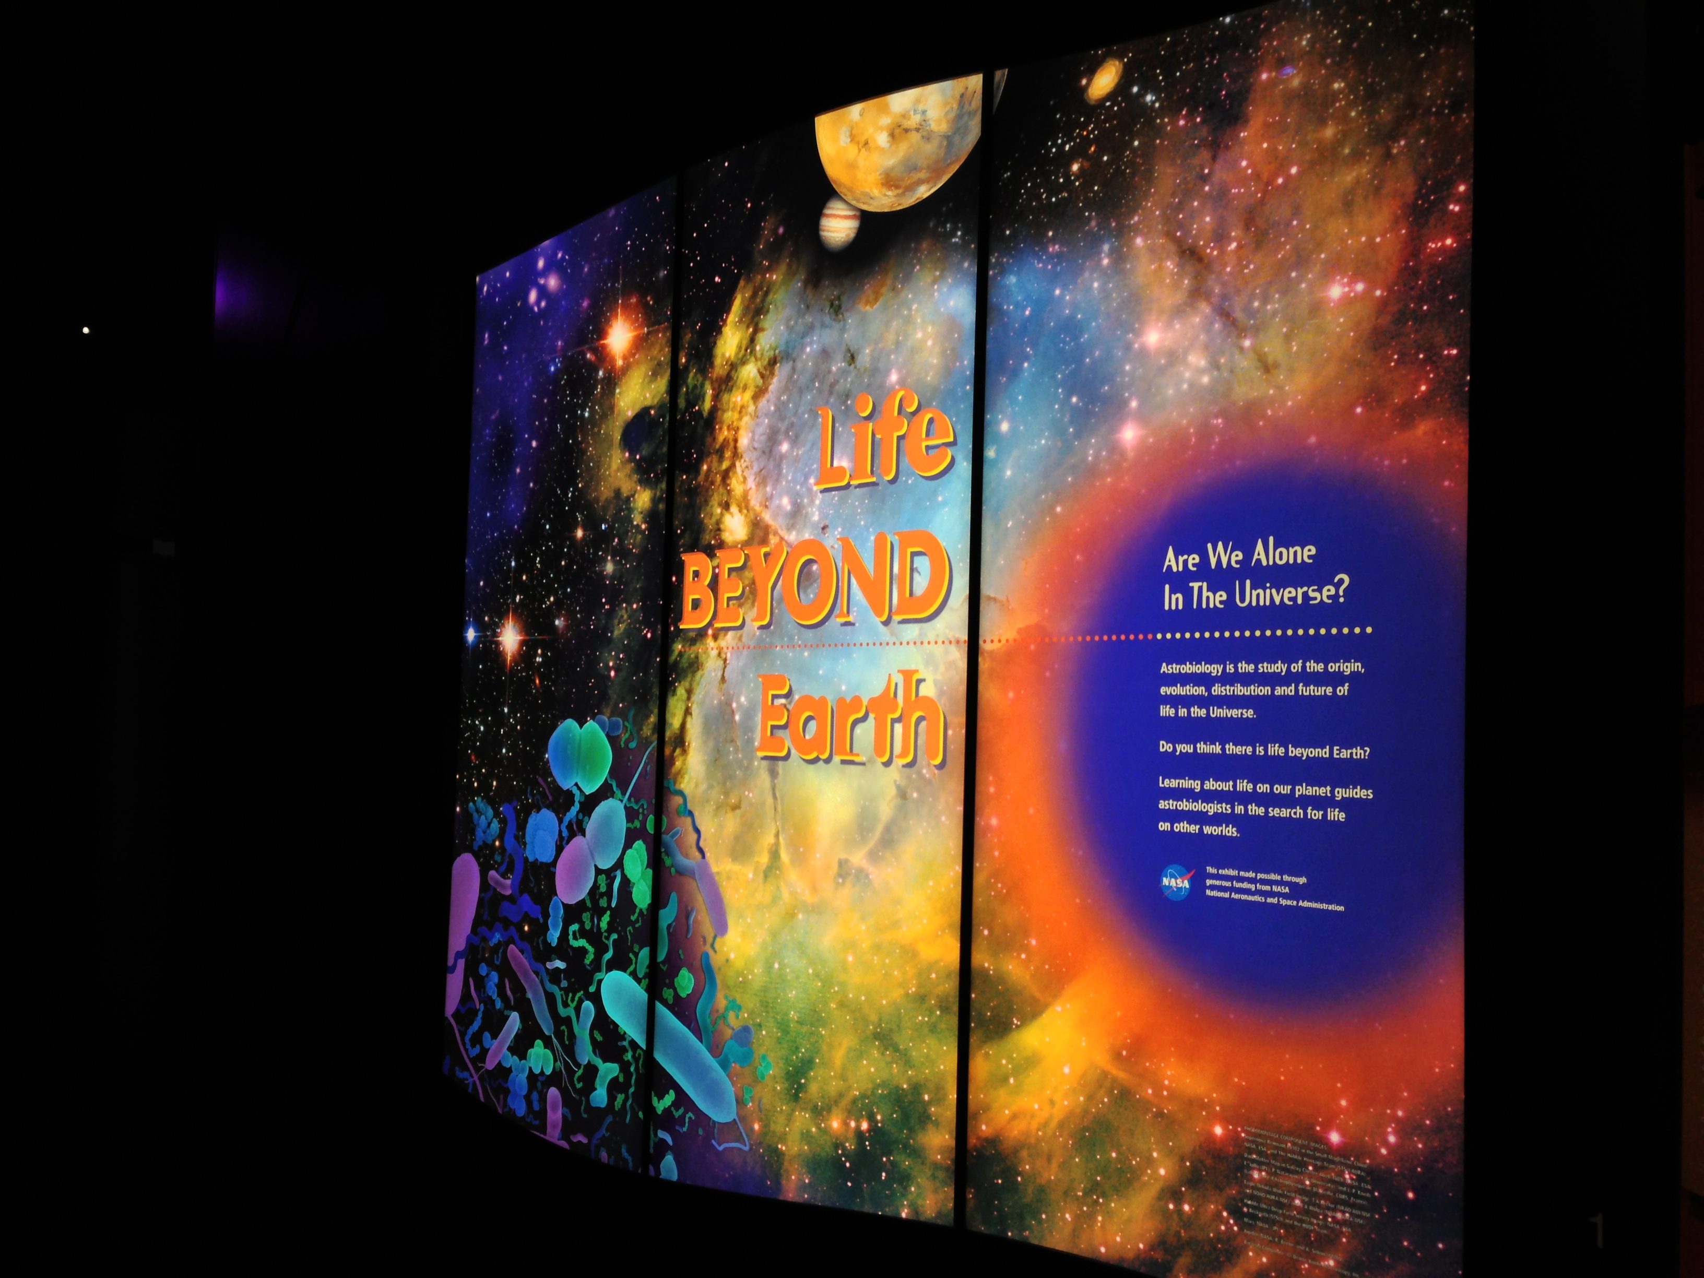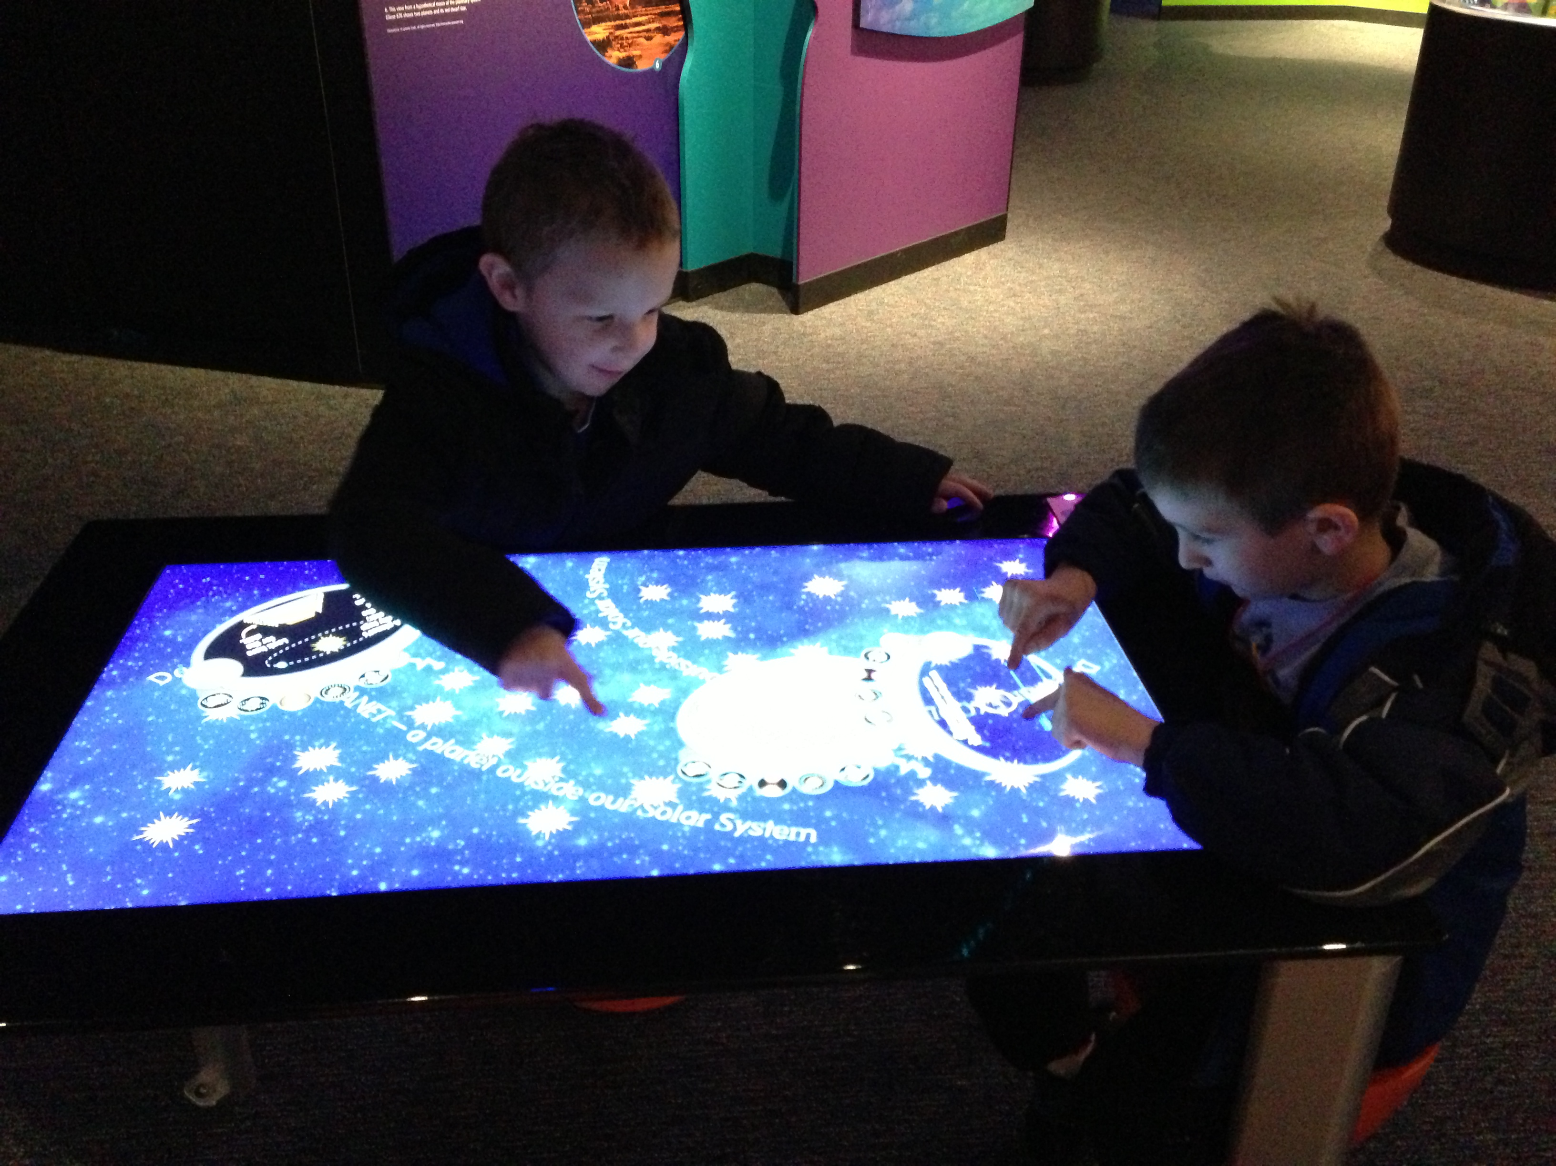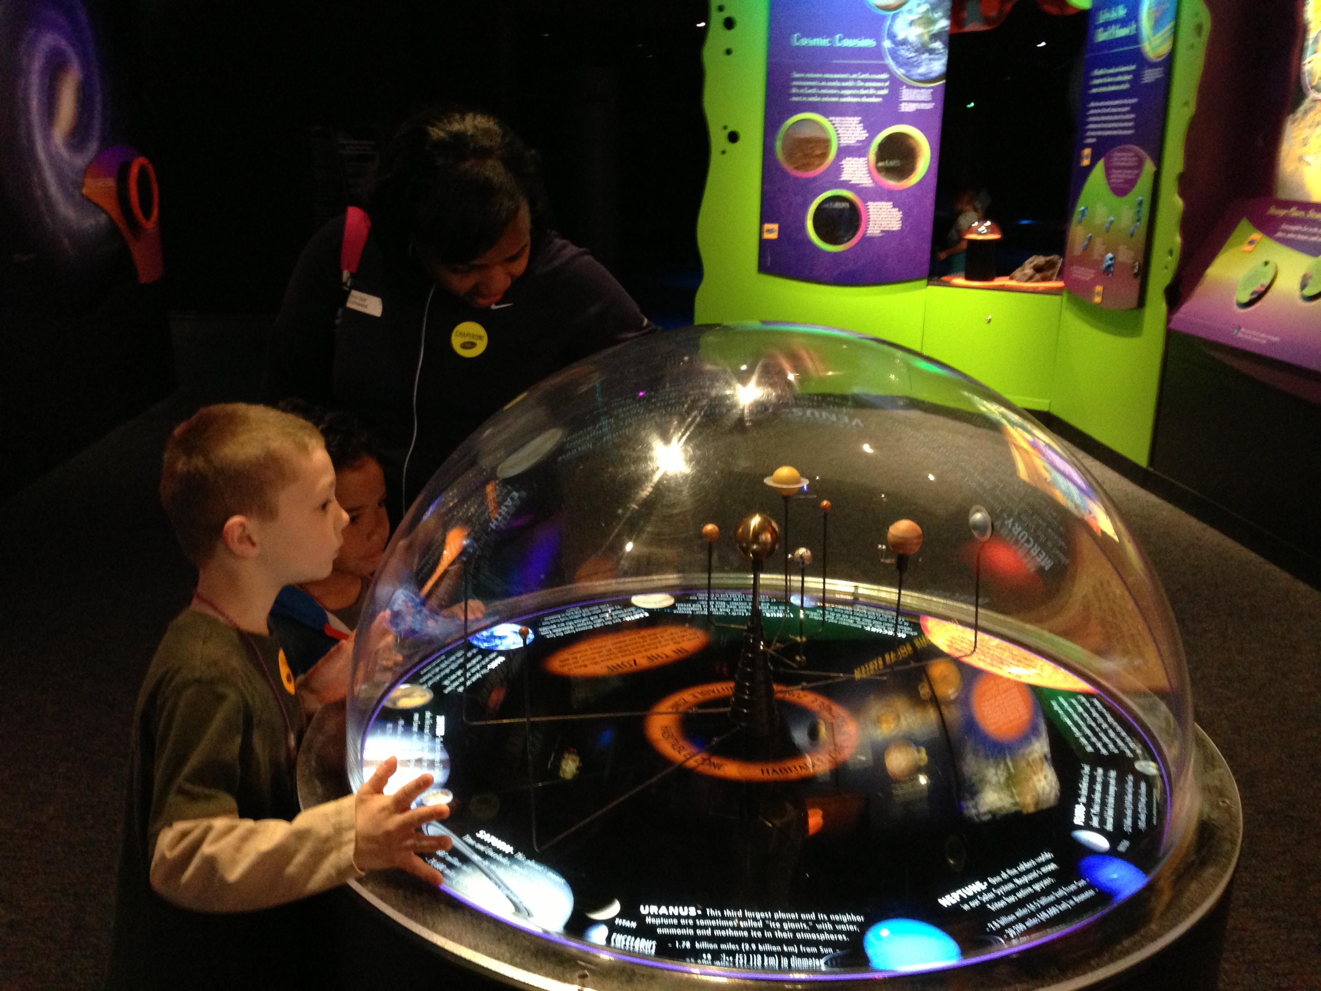

- What was your favorite part of the Life Beyond Earth exhibit? Why?

- Did anything in the exhibit surprise you? Yes No
  - If yes, what?

- Have scientists already found life on other planets? Yes No Not Sure

- What techniques do scientists use to look for planets outside our solar system?

- Do you know how many planets have been found outside our solar system? (Choose one)
  - None
  - Five
  - Around 500
  - Around 100,000

- Why is it hard to find planets that are like Earth?

- What is the scientific term for a planet outside our solar system? (Choose one)
  - Rogue Planet
  - Astroplanet
  - Goldilocks Planet
  - Exoplanet

- What is the scientific field named that studies life in space? (Choose one)
  - Astrobiology
  - Exobiology
  - Alien Biology
  - Extraterrestrial Biology

- How does studying extreme life on Earth help scientists look for life on other planets?

- On a scale of 1-7, with 7 being ‘I’m an Expert’, and 1 being ‘I don’t know much at all’, how much do you know about the search for life on other planets?

 1 – I don’t know much at all | 2 | 3 | 4 | 5 | 6 |  7 –I’m an Expert

