Public Works for Public Learning:
The Golden Gate Bridge Outdoor Exhibition Project

Michelle Phillips, David Heil, Robert Reitherman

While some public works are monumental civil engineering structures like the Eiffel Tower or the Sydney Harbour Bridge, most are commonplace, even invisible, and they are taken for granted. The reason for existence of public works is to provide basic services, but both large and small infrastructure facilities also present opportunities to engage the public in understanding fundamental concepts of Science, Technology, Engineering, and Mathematics (STEM). We review here lessons learned in the National Science Foundation-funded Golden Gate Bridge Outdoor Exhibition project. Using the title of the conference held as part of the project in San Francisco in June, 2012, Public Works for Public Learning, we explore first the opportunities for this type of STEM learning and then the challenges that can arise with such efforts.

The Public Works for Public Learning example focused on here, the Golden Gate Bridge Outdoor Exhibition, grew out of an earlier study supported by NSF that produced the 2008 book Building Bridges Between Civil Engineers and Science Museums authored by Robert (Bob) Reitherman, the Executive Director of the Consortium of Universities for Research in Earthquake Engineering (CUREE) in Richmond, California; Thalia Anagnos, a professor at San Jose State University; and Wendy Meluch of Visitor Studies Services. Reitherman would go on to develop the proposal for the Golden Gate Bridge project in 2008 and serve as project manager and co-principal investigator on it with Denis Mulligan, the project's principal investigator, who at the time of the proposal was Chief Engineer of the Golden Gate Bridge, Highway and Transportation District, and who is now the District's General Manager. The underlying assumption of the project was that approximately 10 million visitors a year come to the bridge as tourists, and, in the words phrased by Mulligan in the proposal that have since come true, "they will come as sightseers, but leave with the experience of having their curiosity piqued by innovative science and engineering exhibits." During a recent evaluation interview, Denis has commented on the origin of the project:

Bob came to me and said ‘this site deserves it.’ It is a fascinating site. But the Bridge District is a transportation agency – we move people from point A to point B, via the Bridge and our ferry and bus systems. Education and interpretation is not what we do… this is quite a different process for us. Developing partnerships with educators and designers who are talented has contributed to our success… We assembled a large team with talent and the requisite skills. They were creative and hardworking.

The Exhibits
First, to explore the positive aspects of Public Works for Public Learning, we review the innovative set of place-based exhibits installed at the visitor area at the San Francisco end of the Golden Gate Bridge. (See http://www.goldengate.org/exhibits.) Later, we discuss some special challenges that come with outdoor exhibits.

The objective of the exhibits was to give visitors insights as to the engineering and construction of the Golden Gate Bridge, especially with regard to these themes:
1. Emphasizing the "why" behind an engineering decision, not just the "what" or the statistic about the completed construction
2. Explaining the thought process of engineers, in particular the idea of trade-offs and competing criteria
3. Including hands-on interactive exhibits, or discover-it-yourself exhibits
4. Directing the visitors' view to an aspect of the bridge itself as they simultaneously stand at an exhibit dealing with that topic.

As one specific example of the first of these themes, a "what" fact is that the 4,200 -foot (1,280-meter) span set the world record when the bridge was completed in 1937. A "why" explanation is given in exhibits that show the undersea topography, which is of course invisible to the visitors: moving the towers closer together would have meant founding them in deeper water, where construction would have been extremely difficult. See Figure 1. Combining a view of the profile of the Golden Gate Strait with photos of divers in their metal diving helmets and air hoses (Figure 2) gives the visitor the visual clues as to why the engineers designed such a long-span structure.

The "why rather than what" learning theme extends to the second point listed above, the engineering trade-off thought process, still very much a part of the practice of civil engineering today. One of the exhibits designed by Dave Fleming of the Exploratorium in San Francisco was an interactive set of three models of the bridge, with three different heights of towers (Figure 3). As a visitor feels the difference in pulling force (tension) required to lift the same-weight deck, the visitor can feel that the tallest tower results in the lowest pulling force. The lower pulling force translates into the need for the smallest steel cables. The shortest tower requires the greatest pulling force in the cables – resulting in the thickest cables. The middle-sized tower actually matches the proportion used in the actual bridge. Why? As built, the towers were the tallest of any bridge in the world. The engineers calculated that making the towers even taller, extending twice as tall above the deck, would have been more costly and difficult than making bigger and stronger cables. Why didn't the engineers pick the design with the shortest towers? Because the trade-off of the smaller cost of towers was overbalanced by the cost of thicker cables and also larger concrete anchorages at both ends of the bridge to resist the larger cable forces.

The third theme the exhibit designers kept in mind was an emphasis on hands-on exhibits paired with more detailed graphic and textual information. The typical visitor experience at the Golden Gate includes a breeze coming through the Golden Gate Strait, hence wind engineering is one of the topics included in the exhibits. An exhibit designed by Aaron Neighbour of CUREE (Figure 4) literally gives the visitor a feel for the variation in wind pressure with wind speed. The display panel of the exhibit provides the details about the fact that the wind pressure varies as the square of the wind speed. For most visitors, however, the learning experience is the feel of pushing on a one-square-foot (one-tenth-square- meter) plate to make a speedometer register the associated wind speed. Another wind engineering exhibit was designed by Princeton University undergraduate Elizabeth Deir, one of ten Princeton engineering students who worked under the direction of co-principal investigator Professor Maria Garlock. According to Professor Garlock, involving engineering students in the project, teaching these young engineers how to convey engineering principles to non-engineers, was one of the broader impacts sought and achieved in this project. The twisting deck exhibit is hands-on; it lets the visitor feel how much greater twisting (torsional) stiffness or resistance one model of the bridge deck has than another. (Figure 5.) The two scale models represent the bridge deck before and after a wind retrofit project was completed in the 1950s and help visitors to understand the “why” of the wind retrofit design.

Two exhibits are actual engineering artifacts -- tried-and-true artifacts, which may seem "old school." Nonetheless actual engineering objects or artifacts still attract and educate visitors. One is a cutaway of a seismic isolator bearing (Figure 6), similar to ones installed on an approach span nearby. Another is a massive steel strut replica of ones in the bridge that is noticeably bent and crumpled (buckled in engineering terms) from testing done in a U.C. Berkeley engineering laboratory. The former illustrates that civil engineering can be a "high-tech" discipline, in which new materials and devices are invented, and the other illustrates that experimentation, not just computer simulation, is how actual engineering is done.

Along with the principles of (1) why-rather-than-what, (2) engineering trade-offs, and (3) hands-on learning, the fourth principle kept in mind by the exhibit designers was directing the visitors' attention to a particular part of the bridge as they simultaneously stand at an exhibit, to capitalize on the site-based aspect of the exhibition. One display that conveys the engineering idea of a load path, the way a weight or load is carried by one structural element to another and finally to the ground, uses wording such as the following:
"Look at the trusses that extend along the length of the bridge," "when you look at the tops of the two towers…." and "see the 500 vertical lines (steel suspender ropes) across the bridge?" See Figure 8.
That exhibit also uses the simple device of a flip or hinged cover, but not in the usual fashion where a question is asked by the display and the answer is revealed when the little door is raised. In this case, the load path diagram of the actual elevation (side view) of the bridge is on top, and matching it under the flip is an animal analogy for the structural work carried out by the different elements of the bridge (Figure 9). (While the flip was placed low to provide the young visitor with an activity and a picture they might find interesting, it turned out that this simple graphic has proven its educational value for adults as well.)

The centerpiece of the entire outdoor exhibition, an 86-foot-long stainless steel scale model of the bridge to tie the individual exhibits together and provide a "table of contents," has been designed but not yet installed, due to a site permit issue, a "challenge" or problem discussed later. See Figure 10. Professor Maria Garlock and Sylvester Black, a Princeton student of hers who has now graduated and is a practicing structural engineer, were charged with designing the very realistically detailed stainless steel model of the bridge, at 1:80 scale. In addition to its planned role as an eye-catching centerpiece, drawing visitors for photo ops to the exhibition area, the numbering on it is planned to correspond to the numbering on the "satellite" ordinary-size exhibits around it. An exhibit dealing with the towers would be numbered to correspond to the number on the towers of the big model, for example.

Website
While the physical exhibits are the heart of the project, the Bridge District’s website (www.goldengate.org/exhibits) provides more detailed information on the exhibit topics, information that can be accessed prior to, during (via QR codes on the exhibits) or after a visit. Professor Thalia Anagnos from San Jose State University helped to develop the content for the website and categorize content with reference to the Next Generation Science Standards, while implementation was handled by Reed Helgens and Darryl Wong of CUREE and Pete Guthlein of the Bridge District.

Evaluation
Two evaluation consultants have been at work on the project, Inverness Research (front-end and formative evaluation) and David Heil and Associates (DHA) (summative). Also part of the evaluation process was a distinguished group of advisors looking over the design team's shoulders: Jill Andrews, University of Michigan; Cathy Frankel, National Building Museum; Alan Friedman, The Museum Group (since deceased); Chris Gallagher, San Francisco Bay Model Visitor Center, US Army Corps of Engineers; Roy Griffiths, North Carolina Museum of Life & Science; Howard Levitt, National Park Service; Larry Lux, Lux Advisors and American Public Works Association (APWA); Joyce Ma, the Exploratorium; Stephen Ressler, United States Military Academy Department of Civil and Mechanical Engineering; and Carol Willis, the Skyscraper Museum. Inverness conducted telephone interviews individually with advisors to obtain additional input from them. In addition, there were several in-person meetings of the entire project team.

DHA developed and delivered with Larry Lux of the American Public Works Association (APWA) an online training course in the APWA continuing education series. DHA surveyed those taking the course before, during, and after, and also used the APWA membership list in May of 2012 to conduct a larger survey of its members.

The data DHA collected from 659 APWA members is shown in Table 1. Only half of the APWA members who completed the survey had “Frequently” heard the terms “Public Outreach” and “Public Education” used to describe the process of reaching out to public audiences, while even fewer (3%) APWA members were familiar with the term "informal science education." This indicates that using terminology that is somewhat private or limited to the informal science education community can be ineffective when communicating with those outside it.

While extensive Public Works for Public Learning activities were uncommon among the members, the majority (95%) of surveyed APWA members still reported using some kind of strategy to connect with their communities. Most frequently, the members used their websites (86%), public hearings (70%), and public newsletters (65%) as vehicles for public outreach. These members also shared that they were most interested in using educational content posted to their agency’s website, interpretive displays at their sites, and public tours to teach their community about local public works. Yet, only a few (16%) of the members reported that their communication with the public “Usually” or "Always" shared the science and engineering involved in their work (Table 2.)

An obvious barrier to a public works agency mounting an informal engineering exhibition is cost. Alternative sources of funding or free labor sources, many of which a public works entity might not think of, are sometimes available and may include businesses with a financial interest in the project – contractors, vendors, suppliers, local visitor-serving businesses like hotels; foundations; local or regional science centers; local professional associations, such as American Society of Civil Engineers or other engineering groups; local universities; civic and service clubs; youth groups; arts or recreation organizations; and historical societies.

The Challenges
EHDD, an architectural firm that has won the AIA (American Institute of Architects) National Firm of the Year award and has designed noteworthy science museums such as the Monterey Bay Aquarium in Monterey, California, did a siting master plan that considered the placement of the "outdoor gallery" where the exhibits would be clustered in sight of the Bridge. Siting turned out to be the key challenge faced by the project. The key architects at EHDD on the project were Chuck Davis, Mark L’Italien, and Phoebe Schenker. While the Bridge District was the NSF awardee, it did not completely control the land within its boundaries -- that power is held by a federal regulatory agency, the National Park Service. The Golden Gate Parks Conservancy was another player. It is the non-profit that has a sole-source relationship with the National Park Service for running various visitor services and improvements at the area around the Bridge as well as other National Park facilities in the region, such as Alcatraz. After the NSF project was underway, the Conservancy advanced ambitious plans that came with significant funding and their own visitor-serving model. A key element was the construction of a new gift store opened in time for the 75th anniversary of the bridge in May, 2012.

The architectural site planning by EHDD had settled on the alternative of remodeling into the exhibition's outdoor gallery or plaza a large 1898 concrete cannon pit built by the U.S. Army. (The cannon was removed prior to World War I, and the area was thereafter little used and not disabled-accessible). Included in the design is making the area completely in conformance with Americans with Disability Act requirements, which the project thought was another strong benefit. However, the federal regulatory agency, the National Park Service, along with the California Office of Historic Preservation, prioritized historic preservation of the concrete features of the 1898 gun fortification walls over the visitor-serving benefits of remodeling that battery. Any removal of the historic concrete, in the form of cutting a ten-foot-wide access and view gateway, surfaced as a major concern, and affecting the dirt berms that had been placed next to walls by the Army in the 1800s was similarly prohibited. As of this writing, the issue is unresolved.

Another challenge has been the nature of the visitors. People end up in science museums by intent. Visitors arrive at the Golden Gate Bridge to see the bridge and go across it, not for the purpose of seeing engineering exhibits. The number of international visitors is quite high at the bridge, which led to the translation of all the panel materials into nine languages plus English, accessible via the website previously discussed. Expectations have to be modest for how long many visitors will dwell at the exhibits. For example, some visitors only have time to set foot on the bridge, hurry to a rest room or the gift shop, and re-board a tour bus.

A small but significant set of visitors have engaged in "visitor misbehavior," ranging from jungle-gym antics by young people, to the usual graffiti, to late-night vandals who use tools. Exhibits located farther from the more trafficked pedestrian areas have experienced the most vandalism, and the well-lit areas covered by security cameras the least. Security hardware has been used throughout. The site presents an environmental problem, the moist and salty atmosphere that accelerates corrosion, but this has been secondary to vandalism. Use of hot-dip galvanized steel and the proper grades of stainless steel has proven adequate.

Other Examples of Public Works for Public Learning
Visitor-serving aspects of some major public works tourist destinations that were presented at the Public Works for Public Learning conference in 2012 are briefly highlighted here.

Eiffel Tower. In the case of the Eiffel Tower, as is the case with the Golden Gate Bridge, the learning opportunity is the engineering monument itself. The Eiffel Tower hosts over 7.1 million visitors a year and on average has 30,000 visitors per day. Exhibits not only explain the design of the tower but its use over the decades in aeronautical, radio communication, and other engineering research. Nicolas Lefebvre, Directeur General of the Eiffel Tower, described at the conference how “backstage” tours are offered for two areas, which helps to distribute the visitors and thus alleviate long lines for the elevators. The first is the machinery for the hydraulic elevators that were uniquely designed for the tower. The second area consists of the underground facilities built for radio communications in the 1920s.

The Eiffel Tower recently updated its exhibits, which constitute an extensive set of displays about the engineer, Gustave Eiffel, to make them more interesting, the dwell times of visitors increased -- a success in terms of interpretive learning, but a trend that affects the through-put of visitors (or inversely, the length of lines to get on the elevators). Finally, while the tower, like the Golden Gate Bridge, is a monument and a visitor destination, it is also a working structure with a large maintenance team that needs to access it while the public visits. For more information see: http://www.toureiffel.paris/

Hoover Dam. Hoover Dam hosts 4,000 visitors a day on carefully choreographed and scheduled tours, using two 40-passenger elevators. At the Public Works for Public Learning conference, William Schermerhorn, Coordinator of Hoover Dam Guide Services and Supervisory Apprentice Coordinator, shared two lessons he has learned through running public programs: listening to visitor input through continual surveys, and supplementing what the visitors want with what the tour staff and engineers know about the dam. As Lefebvre noted concerning the Eiffel Tower, repeat visitors may be nostalgic about its features, and Schermerhorn said:
"Test new exhibit features to make sure they go the way you want them to go. We always have to be aware of the member of the public who will ask about where that interesting exhibit went that was here the last time they visited."

Following the terrorist attacks of September 11, 2001 in New York and Washington, security improvements were begun, which meant more of the tour presentations had to be outdoors -- even when the summertime temperature can reach 120 degrees Fahrenheit (about 50 degrees Celsius). However, after many visitor complaints, the tours were revised to allow visitors the option of moving to an air-conditioned room that was constructed. The tour leaders have learned to keep abreast of maintenance and construction schedules so that docents can be prepared to discuss them with the public and address their questions. The tour staff meets every morning to discuss the operational issues of the day.

The final lesson for Public Works for Public Learning projects that Schermerhorn shared is that visitors are not always eager to self-identify in terms of their accessibility needs (e.g., closed captioning versus open captioning). Therefore, it is critical in these settings to provide a discreet way for visitors to access the assistive technology they could benefit from, without it being a conspicuous process. For more information see: http://www.usbr.gov/lc/hooverdam/service.

Panama Canal. Javier Pinzon Pascal, Manager of the Power Controls Office for the Panama Canal Authority, spoke at the PWPL conference about the massive Canal expansion program that began in 2007, is expected to be completed in 2015, and which will double the Canal's capacity and allow for the newer, larger ships. The needs of visitors were not overlooked in this massive public works project. A new visitor center is being built, near the Bridge of the Americas (the entrance to the canal from the Pacific side). The Miraflores Visitor Center on the Atlantic side is being expanded, and a third bridge over the Canal is under construction that will offer viewing opportunities on the Atlantic side, in addition to the Centennial Bridge, which opened in 2005.

In Panama, visitor centers are considered investment programs, just as the bridges that have to be built to cross the Canal, and these investments must be approved by the President of Panama. Therefore, it has been critical to make the case for the value and potential return on investment that the visitor centers can realize. It is the cruise ships that pay the most for Canal access ($500,000 for one transit), so the Canal pays special attention to them, providing tourist handlers and easy transportation routes that will take passengers to the visitor centers. For more information see: www.pancanal.com

Sydney Harbour Bridge. John Bowe described Bridge Climb Sydney, a program that has taken nearly 3 million visitors on a climb over the top of arched Sydney Harbour Bridge. When Bridge Climb first submitted its proposal to allow visitors to climb the bridge, they were handed a list of 64 reasons they would not be allowed to do so, including the risks of visitors dropping keys and jewelry onto vehicles or pedestrians below, lights being flashed in drivers’ eyes, visitors falling, and security. To obtain the go-ahead for the tour program, each of the 64 issues had to be successfully addressed. For example, a special suit for the climb was developed that includes a special tether or attachment device connecting the visitors to the structure; a metal detector and breathalyzer test screens visitors prior to their climb; and wet and cold weather gear is provided to protect the visitors from the elements. Climb leaders do not have a rote script, and the content has changed over time. As, John Bowe from Bridge Climb Sydney said:

You have to add value, enhance the story. One of the greatest personal pleasures that I had was that once we gained the trust of the workers on the bridge, they started to bring out the stories and materials they had hidden away. We seek to facilitate access for others to the story.

For more information see: http://www.bridgeclimb.com/

WaterWorks at Arizona Falls. The Public Works for Public Learning conference featured several examples of small-scale projects using public works facilities as learning resources: most public facilities are small, not monumental. WaterWorks at Arizona Falls in Phoenix is a small hydroelectric plant with waterfall, a public art exhibition space, and a recreation facility, all in one. It is operated by the Salt River Project utility, which supplies water and power to the Phoenix region. The power generation of the restored facility is nominal, but the utility took the effort to bring together different local interests to preserve and remodel the facility for multi-use purposes. It had formerly been a gathering place for local residents, and it was part of the history of the development of the region. As Jim Duncan from Arizona Falls said at the conference:
"Residents and visitors cannot appreciate the Salt River Valley if they don’t know the story." See Figure 11.

The renovation involved funding from the Salt River Project along with the Bureau of Reclamation and the City of Phoenix Office of Arts and Culture. PBS has filmed episodes of Sid the Science Kid at the site, and it has hosted science festivals there. Public art activities, marathons, craft fairs, and tours focused on sustainability and irrigation are also held there, and the site is connected to 132 miles of canal lined with a multi-use trail and interpretive signs.

Arizona Falls itself is a popular tourist destination every year when fish used in the canal to keep algae under control are rounded up. Workers pick them up and move them to an adjacent temporarily walled off section of the canal while the water is drained to remove debris. Recently, this roundup has been called The Art of Maintenance, with opportunities for high school students and residents to create art out of the objects found in the canal. For example, high school students created a 14-foot alligator out of the found debris, a sculpture that later traveled around the country). For more information see: http://www.srpnet.com/water/canals/azfalls.aspx

Conclusions
Have Public Works for Public Learning efforts been successful as innovative ways to deliver STEM learning in diverse settings? Yes. And are there special challenges involved? Yes: a number of those have been highlighted in this brief review. Both the engineering community that designs and operates public works and the public that pays for and uses the services of these facilities are largely untapped outreach opportunities or "markets." If you look around your community, you may find potential partners and sites where a successful Public Works for Public Education project can be accomplished.

Table 1: Survey of APWA Members on Terminology
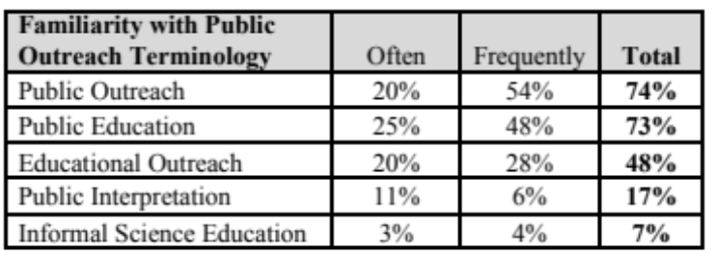
David Heil & Associates

Table 2: Survey of APWA Members on How Often They Have Engineering and Science Educational Programs

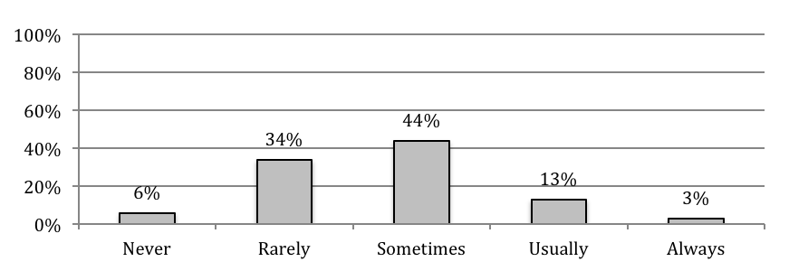
David Heil & Associates

Figure 1: Undersea Topography Reveals Why the Bridge Spanned So Far
Moving the towers closer together would have meant construction work in deep water. This Braille exhibit, part of the Golden Gate Bridge Outdoor Exhibition, works for the seeing and sight-impaired alike. (Tactile undersea topography outline highlighted in this photo with dashed white line and arrow). Design by Tara Weigand and Professor Maria Garlock, Princeton University (3D digital modeling); Bob Reitherman, CUREE (overall design); Lighthouse for the Blind and Visually Impaired (user interaction); and Cinnabar (fabrication).

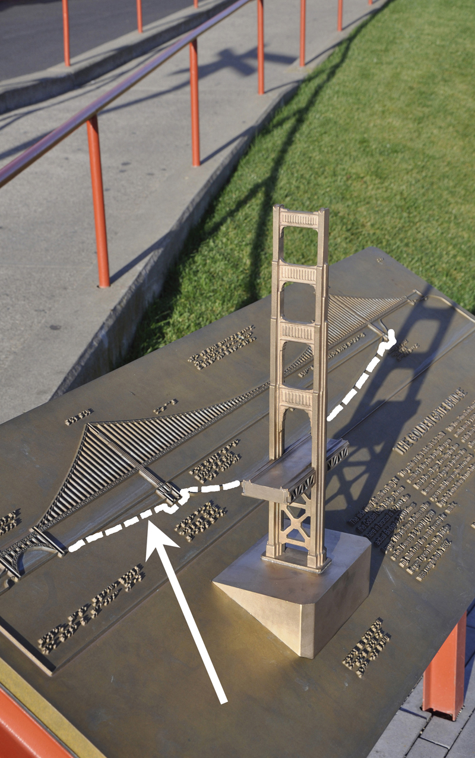

Figure 2: Explaining How the Foundations Were Built
One of nine history panels tracing the "biography" of the Golden Gate Bridge. Design by Reed Helgens and Darryl Wong, CUREE.

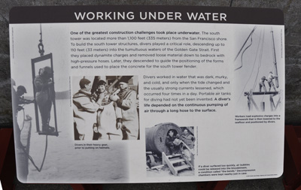

Figure 3: The Height of the Towers of a Suspension Bridge
The greater the distance from top of tower down to the bottom of the sag of the cables, the more efficiently the cables can lift the weight of the deck. The trade-off is that the cost and difficulty of building taller towers would have outweighed that cost savings. Design by David Fleming, the Exploratorium.

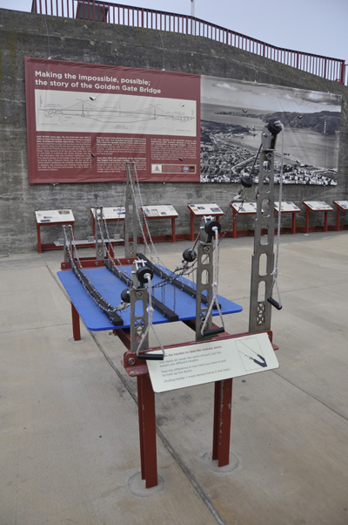

Figure 4: Visitors Literally Get a Feel for Wind Pressure
The display's words and numbers explain that the wind pressure on the bridge varies as the square of the wind speed -- but pushing on the plate to make the speedometer read out a given wind speed quickly gives the visitor a feel for that principle. Design by Aaron Neighbour, CUREE.

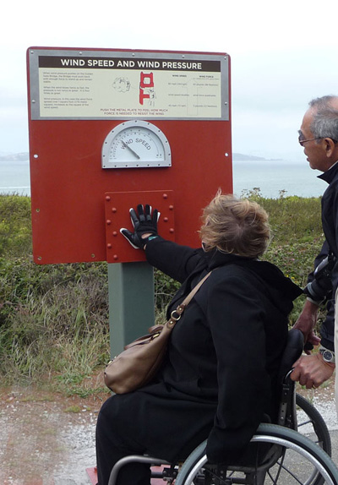

Figure 5: Feeling the Difference in Original and Retrofitted Decks
The Golden Gate Bridge was retrofitted in 1953-1954 to increase the torsional (twisting) stiffness and strength of the deck. These two models let the visitors immediately feel that difference. Design by Elizabeth Deir, Princeton University.

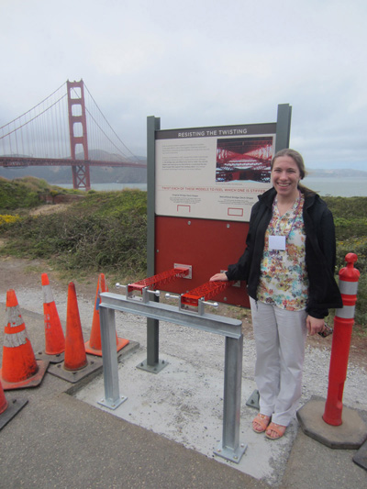

Figure 6: Cut-a-way view of a Seismic Isolator
Approach spans to the bridge are mounted on seismic isolators. The exhibit shows an actual one cut in half to reveal its steel-rubber sandwich construction. Design by Bob Reitherman, CUREE; isolator by Dynamic Isolation Systems.

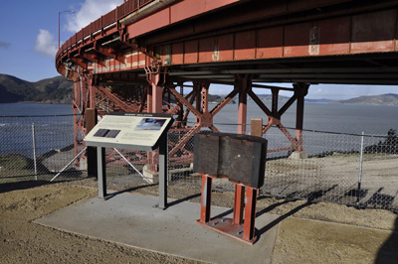

Figure 7: Strut Tested to Assess Strength of Bridge Struts
This portion of a tall strut was made identically to one of the original struts on the bridge, then tested in a University of California civil engineering laboratory. Professor A. Astaneh-Asl.
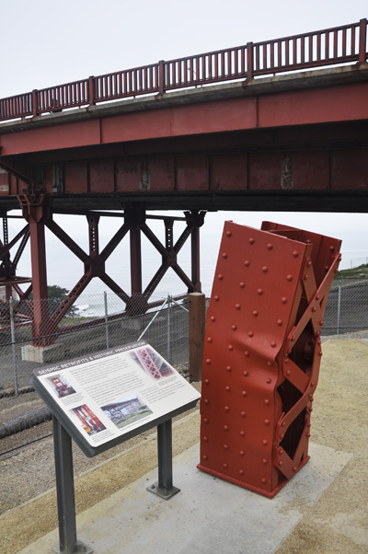

Figure 8: The Engineering Concept of a Load Path
Visible features of the bridge are the signs of how the gravity load of the weight of the deck and its traffic is held up. Design by Bob Reitherman, CUREE.

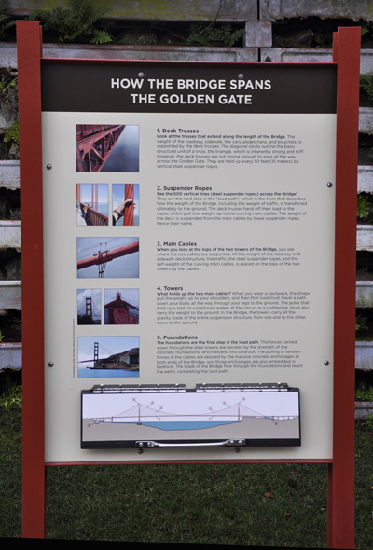

Figure 9: The Animal Analogy for a Suspension Bridge
When the "flip" door is raised, the same information as was presented above in the display with words is conveyed using only graphics. Design by Bob Reitherman, CUREE
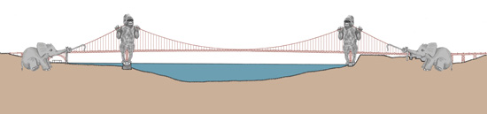

Figure 10: The Centerpiece and "Table of Contents" Model
Chief designer Sylvester Black and Princeton professor Maria Garlock designed an entire Golden Gate Bridge -- every strut, every cable -- at a scale of 1:80 (80 times smaller than the actual bridge). It is shown in its intended "outdoor gallery" with satellite exhibits around it. Rendering by Doron Serban

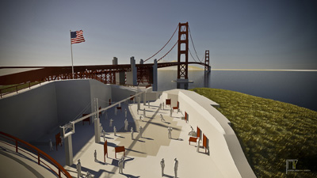

Figure 11: WaterWorks at Arizona Falls
A former hydroelectric plant has been given new life, combining art and science exhibition and recreation opportunities. Salt River Project

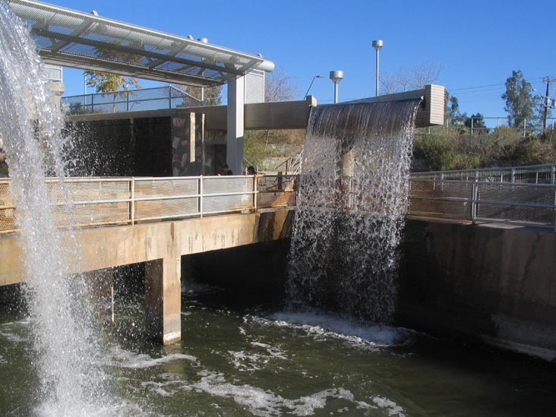

Notes

Inverness Research, Inverness, California.
David Heil Associates, Portland, Oregon.
CUREE, Richmond, California.
The Golden Gate Bridge as an Informal Science Education Resource, also known as the Golden Gate Bridge Outdoor Exhibition project, funded under NSF award 0840185. Any opinions, findings, and conclusions or recommendations expressed here are those of the authors and do not necessarily reflect the views of the National Science Foundation.
Building Bridges Between Civil Engineers and Science Museums, CUREE, Richmond, CA, 2008; available for free download at: http://www.curee.org/projects/ce-museums/monograph.html

